Question No : 1 -

You manage a solution deployed in two Azure subscriptions for testing and production.  
Both subscriptions have virtual networks named fabVNet.  
You plan to add two new virtual machines (VMs) in a new subnet.  
You have the following requirements:  
Which three steps should you perform in sequence? To answer, move the appropriate  
actions from the list of actions to the answer area and arrange them in the correct order.

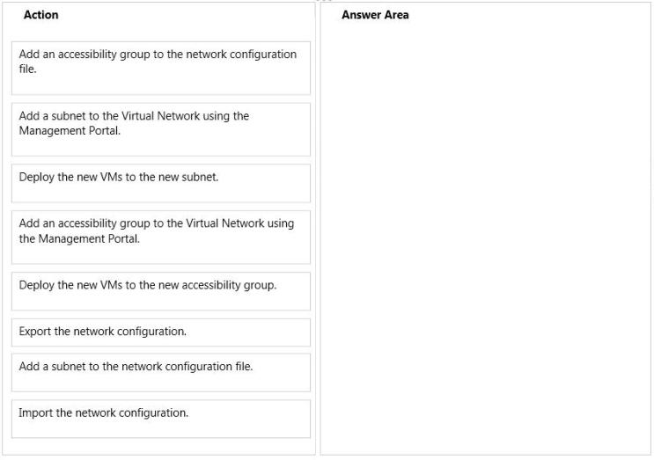

question_answerVIEW ANSWER

SHOW COMMENTS15

Answer :

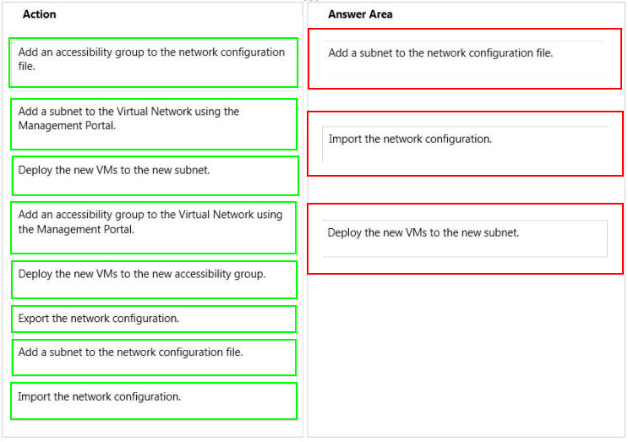

Explanation: Box 1: Add a subnet to the network configuration file. Box 2: Import the network configuration. Box 3: Deploy the new VMs to the new subnet. After youve configured your network configuration file, use the procedure below to import it into the Management Portal. To import a network configuration file: References:

Question No : 2 -

You administer an Azure Web Site named contoso. The development team has  
implemented changes to the website that need to be validated.  
You need to validate and deploy the changes with minimum downtime to users.  
What should you do first?

* A. Create a new Linked Resource.
* B. Configure Remote Debugging on contoso.
* C. Create a new website named contosoStaging.
* D. Create a deployment slot named contosoStaging.
* E. Back up the contoso website to a deployment slot.

question_answerVIEW ANSWER

SHOW COMMENTS7

Answer : D

Explanation: The deployment slots feature for Azure Websites allows validating a version of your site with full content and configuration updates on the target platform before directing customer traffic to this version. The expectation is that a deployment slot would be fully configured in the desired target format before performing a swap. References:

Question No : 3 -

Your company network includes users in multiple directories.  
You plan to publish a software-as-a-service application named SaasApp1 to Azure Active  
Directory.  
You need to ensure that all users can access SaasApp1.  
What should you do?

* A. Configure the Federation Metadata URL
* B. Register the application as a web application.
* C. Configure the application as a multi-tenant.
* D. Register the application as a native client application.

question_answerVIEW ANSWER

SHOW COMMENTS2

Answer : C

Explanation: * When you get deeper into using Windows Azure Active Directory, youll run into new terminology. For instance, is called "directory" is also referred to as a Windows Azure AD Tenant or simply as "tenant." This stems from the fact that WAAD ()Windows Azure Active Directory is a shared service for many clients. In this service, every client gets its own separate space for which the client is the tenant. In the case of WAAD this space is a directory. This might be a little confusing, because you can create multiple directories, in WAAD terminology multiple tenants, even though you are a single client. * Multitenant Applications in Azure A multitenant application is a shared resource that allows separate users, or "tenants," to view the application as though it was their own. A typical scenario that lends itself to a multitenant application is one in which all users of the application may wish to customize the user experience but otherwise have the same basic business requirements. Examples of large multitenant applications are Office 365, Outlook.com, and visualstudio.com. References:

Question No : 4 -

You manage an Azure subscription.  
You develop a storage plan with the following requirements:  
In the table below, identify the storage redundancy type that must be used. Make only one  
selection in each column.

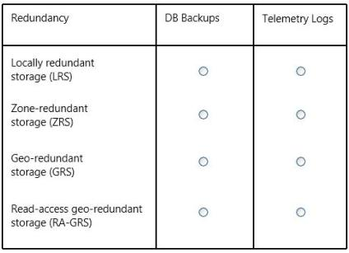

question_answerVIEW ANSWER

SHOW COMMENTS3

Answer :

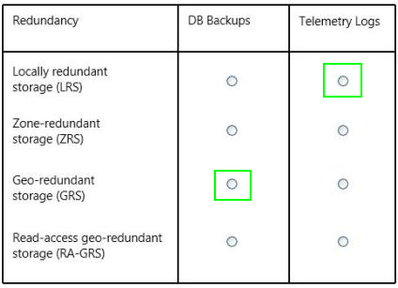

Question No : 5 -

You manage a web application published to Azure Cloud Services.  
Your service level agreement (SLA) requires that you are notified in the event of poor  
performance from customer locations in the US, Asia, and Europe.  
You need to configure the Azure Management Portal to notify you when the SLA  
performance targets are not met.  
What should you do?

* A. Create an alert rule to monitor web endpoints.
* B. Create a Notification Hub alert with response time metrics.
* C. Add an endpoint monitor and alert rule to the Notification Hub.
* D. Configure the performance counter on the cloud service.

question_answerVIEW ANSWER

SHOW COMMENTS1

Answer : A

Explanation: * An alert rule enables you to monitor an available metric within a supported Azure service. When the value of a specified metric violates the threshold assigned for a rule, the alert rule becomes active and registers an alert. When you create an alert rule, you can select options to send an email notification to the service administrator and co-administrators, or another administrator, when the rule becomes active, and when an alert condition is resolved. * You can configure cloud service alert rules on: Web endpoint status metrics Monitoring metrics from the cloud service host operating system Performance counters collected from the cloud service guest virtual machine References:

Question No : 6 -

You manage an Azure Web Site for a consumer-product company.  
The website runs in Standard mode on a single medium instance.  
You expect increased traffic to the website due to an upcoming sale during a holiday  
weekend.  
You need to ensure that the website performs optimally when user activity is at its highest.  
Which option should you select? To answer, select the appropriate option in the answer  
area.

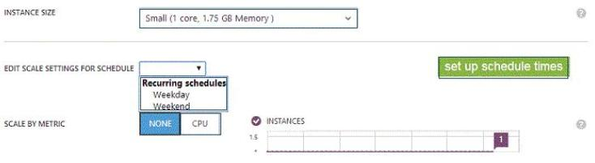

question_answerVIEW ANSWER

SHOW COMMENTS3

Answer :

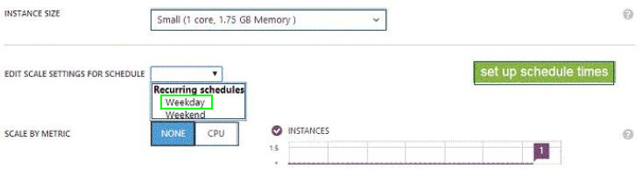

Explanation:

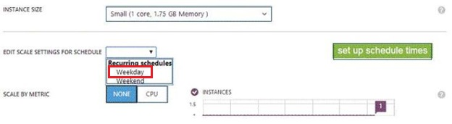

Note: The small instance is selected. This setting would be for the weekdays. Then you would select a larger instance for the weekend schedule setting to cover the increased activity. References:

Question No : 7 -

You deploy an ASP.NET application to an Azure Cloud Service.  
You must collect telemetry data for troubleshooting performance issues and resource  
usage.  
You need to configure Azure diagnostics.  
For each requirement, which data source should you specify? To answer, select the  
appropriate data source from each list in the answer area.

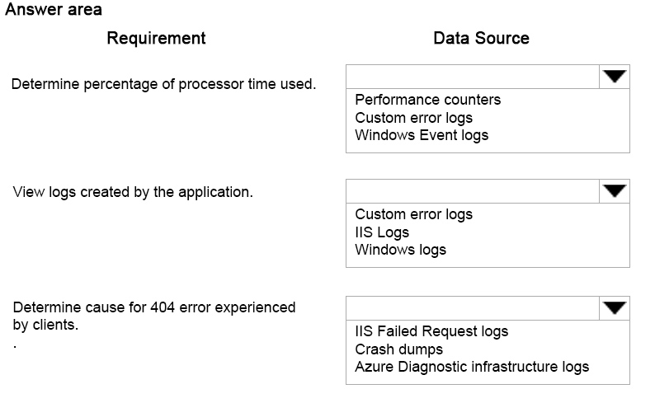

question_answerVIEW ANSWER

SHOW COMMENTS0

Answer :

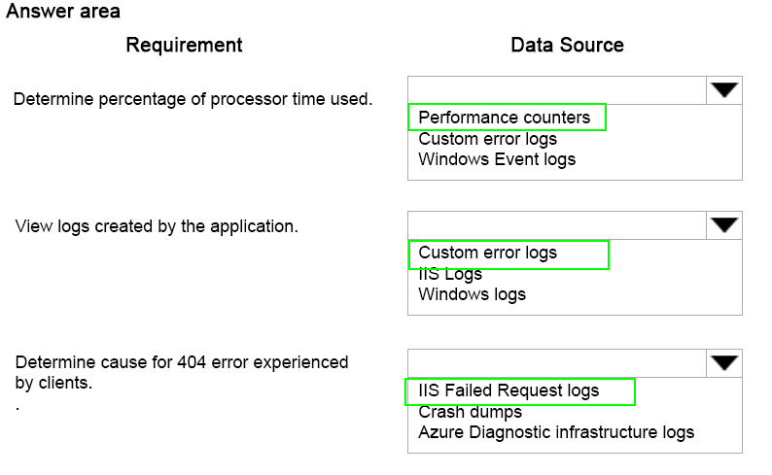

Explanation:

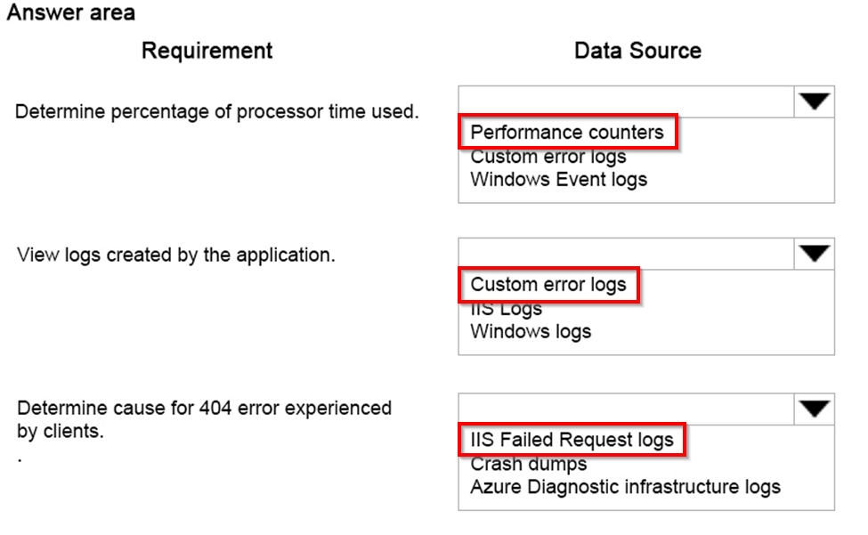

References: https://azure.microsoft.com/en-us/documentation/articles/azure-diagnostics/#cloud-services

Question No : 8 -

You plan to deploy a cloud service named contosoapp that has a web role named  
contosoweb and a worker role named contosoimagepurge.  
You need to ensure the service meets the following requirements:  
Which configuration should you use? To answer, drag the appropriate configuration setting  
to the correct location in the service configuration file. Each configuration setting may be  
used once, more than once, or not at all. You may need to drag the split bar between  
panes or scroll to view content.

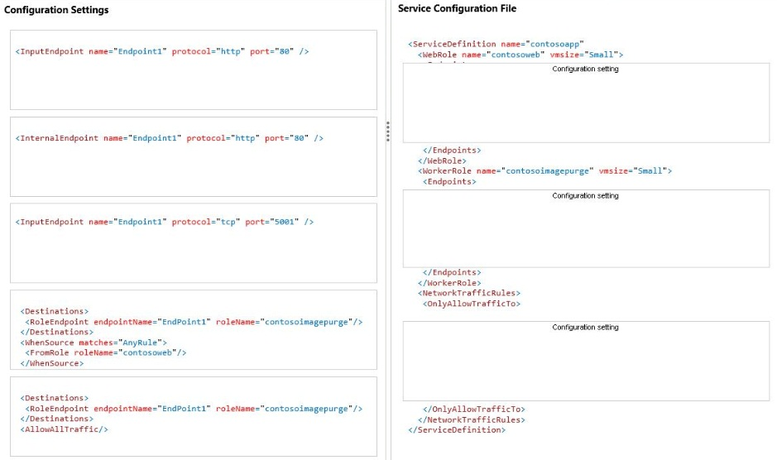

question_answerVIEW ANSWER

SHOW COMMENTS2

Answer :

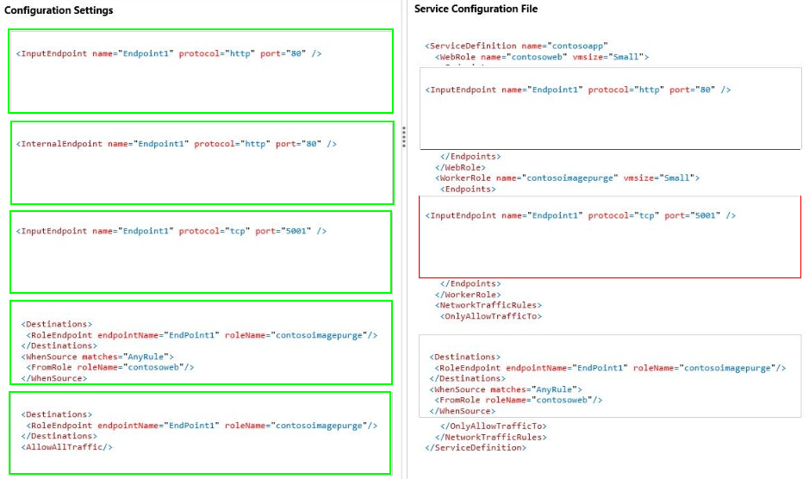

Question No : 9 -

You administer a virtual machine (VM) that is deployed to Azure. You configure a rule to  
generate an alert when the average availability of a web service on your VM drops below  
95 percent for 15 minutes.  
The development team schedules a one-hour maintenance period.  
You have the following requirements:  
You want to achieve this goal by using the least amount of administrative effort.  
What should you do from the Management Portal?

* A. Select and disable the rule from the Dashboard page of the virtual machine.
* B. Select and delete the rule from the Configure page of the virtual machine.
* C. Select and disable the rule from the Monitor page of the virtual machine.
* D. Select and disable the rule on the Configure page of the virtual machine.

question_answerVIEW ANSWER

SHOW COMMENTS4

Answer : C

Explanation: * Example:

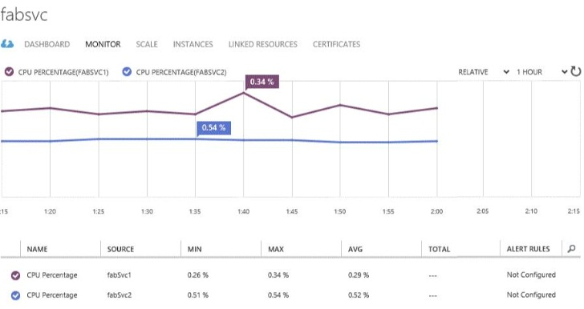

* Virtual Machines You can configure virtual machine alert rules on: / Monitoring metrics from the virtual machine host operating system / Web endpoint status metrics References:

Question No : 10 -

You have a virtual machine (VM) that must be secured. Direct access to the VM is not  
permitted. You create the following Azure PowerShell script. Line numbers are included for  
reference only.

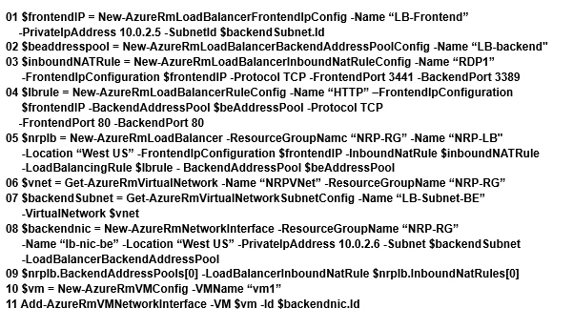

You assign the virtual network to the variable $vnet. You assign the subnet to the variable  
$backendSubnet. For each of the following statements, select Yes if the statement is true.  
Otherwise, select No.

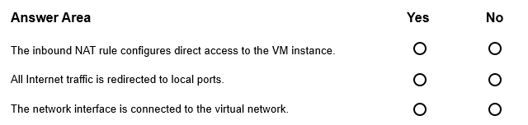

question_answerVIEW ANSWER

SHOW COMMENTS0

Answer :

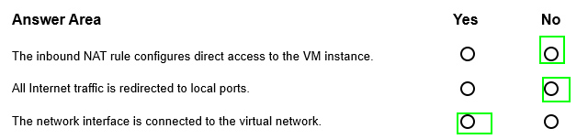

Question No : 11 -

You develop a set of Power Shell scripts that will run when you deploy new virtual  
machines (VMs).  
You need to ensure that the scripts are executed on new VMs. You want to achieve this  
goal by using the least amount of administrative effort.  
What should you do?

* A. Create a new GPO to execute the scripts as a logon script.
* B. Create a SetupComplete.cmd batch file to call the scripts after the VM starts.
* C. Create a new virtual hard disk (VHD) that contains the scripts.
* D. Load the scripts to a common file share accessible by the VMs.
* E. Set the VMs to execute a custom script extension.

question_answerVIEW ANSWER

SHOW COMMENTS0

Answer : E

Explanation: After you deploy a Virtual Machine you typically need to make some changes before its ready to use. This is something you can do manually or you could use Remote PowerShell to automate the configuration of your VM after deployment for example. But now theres a third alternative available allowing you customize your VM: the CustomScript extension. This CustomScript extension is executed by the VM Agent and its very straightforward: you specify which files it needs to download from your storage account and which file it needs to execute. You can even specify arguments that need to be passed to the script. The only requirement is that you execute a .ps1 file. References:

Question No : 12 -

You administer a Microsoft Azure SQL Database database in the US Central region named  
contosodb. Contosodb runs on a Standard tier within the SI performance level.  
You have multiple business-critical applications that use contosodb.  
You need to ensure that you can bring contosodb back online in the event of a natural  
disaster in the US Central region. You want to achieve this goal with the least amount of  
downtime.  
Which two actions should you perform? Each correct answer presents part of the solution.

* A. Upgrade to S2 performance level.
* B. Use active geo-replication.
* C. Use automated Export.
* D. Upgrade to Premium tier.
* E. Use point in time restore.
* F. Downgrade to Basic tier.

question_answerVIEW ANSWER

SHOW COMMENTS3

Answer : B,D

Explanation: B: The Active Geo-Replication feature implements a mechanism to provide database redundancy within the same Microsoft Azure region or in different regions (geo- redundancy). One of the primary benefits of Active Geo-Replication is that it provides a database-level disaster recovery solution. Using Active Geo-Replication, you can configure a user database in the Premium service tier to replicate transactions to databases on different Microsoft Azure SQL Database servers within the same or different regions. Cross-region redundancy enables applications to recover from a permanent loss of a datacenter caused by natural disasters, catastrophic human errors, or malicious acts. D: Active Geo-Replication is available for databases in the Premium service tier only. References:

Question No : 13 -

Your company network includes an On-Premises Windows Active Directory (AD) that has a  
DNS domain named contoso.local and an email domain named contoso.com. You plan to  
migrate from On-Premises Exchange to Office 365.  
You configure DirSync and set all Azure Active Directory {Azure AD) usernames as  
%username%@contoso.com  
You need to ensure that each user is able to log on by using the email domain as the  
username.  
Which two actions should you perform? Each correct answer presents part of the solution.

* A. Verify the email domain in Azure AD domains.
* B. Run the Set-MsolUserPrincipalName -UserPrincipalName %username%@contoso.onmicrosoft.com -NewUserPrincipalName %usemame %@contoso.com Power Shell cmdlet.
* C. Edit the ProxyAddress attribute on the On-Premises Windows AD user account.
* D. Verify the Windows AD DNS domain in Azure AD domains.
* E. Update the On-Premises Windows AD user account UPN to match the email address.

question_answerVIEW ANSWER

SHOW COMMENTS11

Question No : 14 -

You administer an Azure Active Directory (Azure AD) tenant.  
You add a custom application to the tenant.  
The application must be able to:  
In the table below, identify the permission that must be granted to the application. Make  
only one selection in each column.

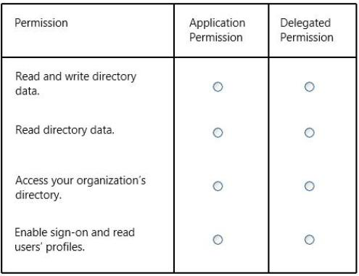

question_answerVIEW ANSWER

SHOW COMMENTS2

Question No : 15 -

You have an application that uses an Azure SQL Database.  
The database becomes corrupt and is not usable.  
You must configure point in time recovery to replace the database.  
Which three actions should you perform in sequence? To answer, move the appropriate  
actions from the list of actions to the answer area and arrange them in the correct order.

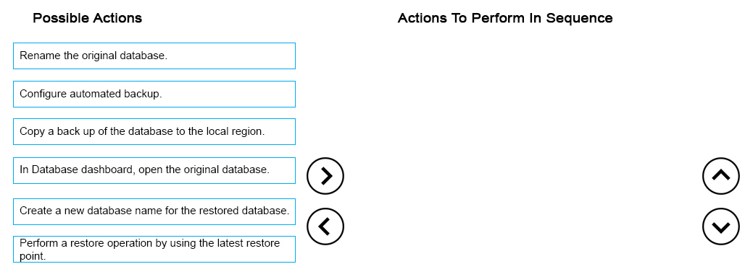

question_answerVIEW ANSWER

SHOW COMMENTS1

Answer :

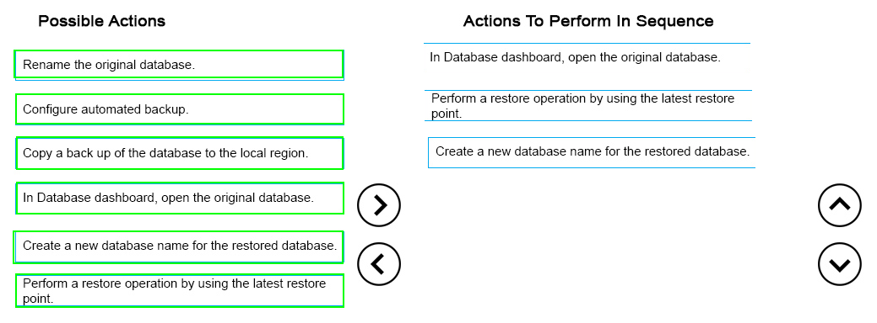

Explanation:

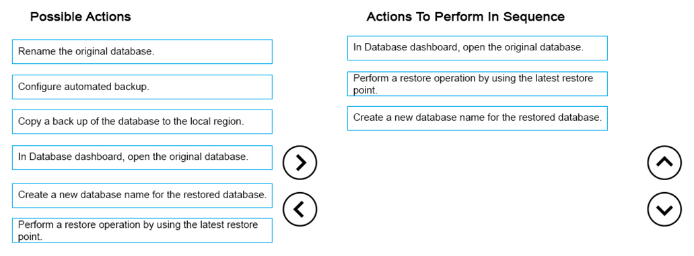

References: https://azure.microsoft.com/en-gb/blog/azure-sql-database-point-in-time-restore/

Question No : 16 -

You administer a Microsoft Azure SQL Database data base in the US Central region  
named contosodb. Contosodb runs on a Standard tier within the S1 performance level.  
You have multiple business-critical applications that use contosodb.  
You need to ensure that you can bring contosodb back online in the event of a natural  
disaster in the US Central region. You want to achieve this goal with the least amount of  
downtime.  
Which two actions should you perform? Each correct answer presents part of the solution.

* A. Upgrade to S2 performance level.
* B. Use active geo-replication.
* C. Use automated Export.
* D. Upgrade to Premium tier.
* E. Use point in time restore.
* F. Downgrade to Basic tier.

question_answerVIEW ANSWER

SHOW COMMENTS4

Answer : B,D

Explanation: B: The Active Geo-Replication feature implements a mechanism to provide database redundancy within the same Microsoft Azure region or in different regions (geo- redundancy). One of the primary benefits of Active Geo-Replication is that it provides a database-level disaster recovery solution. Using Active Geo-Replication, you can configure a user database in the Premium service tier to replicate transactions to databases on different Microsoft Azure SQL Database servers within the same or different regions. Cross-region redundancy enables applications to recover from a permanent loss of a datacenter caused by natural disasters, catastrophic human errors, or malicious acts. D: Active Geo-Replication is available for databases in the Premium service tier only. References:

Question No : 17 -

You administer an Azure Virtual Machine (VM) named CON-CL1. CON-CL1 is in a cloud  
service named ContosoService1.  
You want to create a new VM named MyApp that will have a fixed IP address and be  
hosted by an Azure Datacenter in the US West region.  
You need to assign a fixed IP address to the MyApp VM.  
Which Azure Power Shell cmdlets and values should you use? To answer, drag the  
appropriate cmdlet or value to the correct location in the PowerShell command. Each  
cmdlet or value may be used once, more than once, or not at all. You may need to drag the  
split bar between panes or scroll to view content

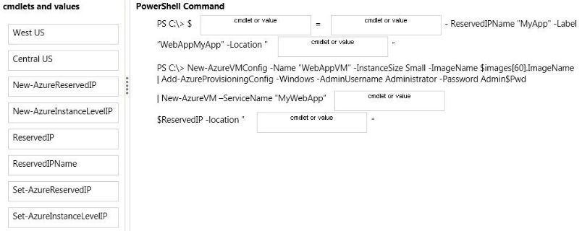

question_answerVIEW ANSWER

SHOW COMMENTS2

Answer :

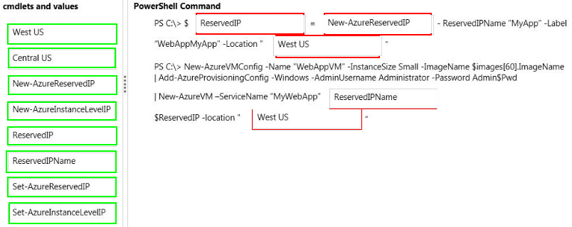

Explanation:

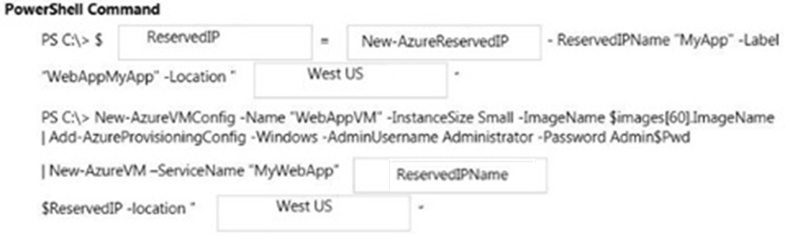

Create a Reserved IP and associate it with a cloud service (Virtual Machines) Use the following script as a template to create a Reserved IP and then use the Reserved IP to create a cloud service deployment (Virtual Machines). $ReservedIP = New-AzureReservedIP -ReservedIPName "FirewallIP" -Label "WebAppFirewallIP" -Location "Japan West" New-AzureVMConfig -Name "WebAppVM" -InstanceSize Small -ImageName $images[60].ImageName | Add-AzureProvisioningConfig -Windows -AdminUsername cloudguy -Password Abc123 | New-AzureVM -ServiceName "WebApp" ReservedIPName $ReservedIP -Location "Japan West" References:

Question No : 18 -

You have an Azure Web App that uses the URL contoso.azurewebsites.net. The virtual IP  
address of the web app is subject to change.  
Users must be able to navigate to a custom domain name to access the Web App. You set  
up the DNS records for a custom domain at a third party registrar.  
You need to configure the web app to use the custom domain name.  
For each mapping, which DNS record type should you create? To answer, select the  
appropriate DNS record type from each list in the answer area.

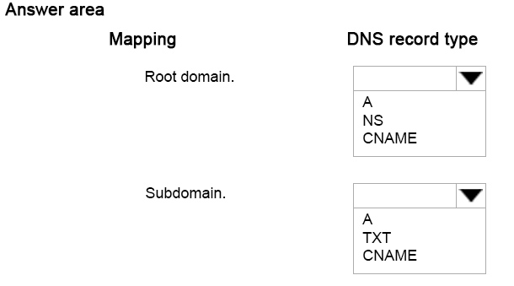

question_answerVIEW ANSWER

SHOW COMMENTS0

Answer :

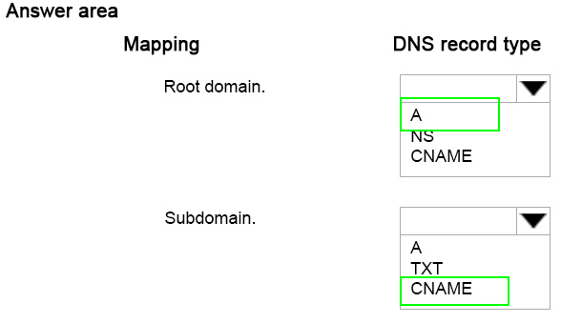

Explanation:

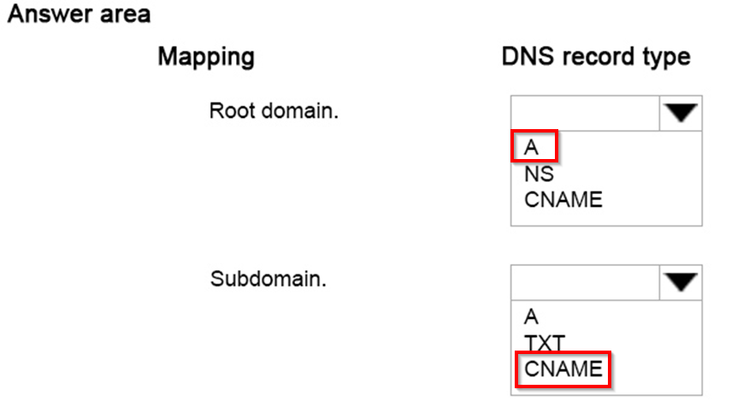

References: https://azure.microsoft.com/en-gb/documentation/articles/web-sites-custom-domain-name/

Question No : 19 -

You are the administrator for three Azure subscriptions named Dev, Test, and Prod.  
Your Azure Power Shell profile is configured with the Dev subscription as the default.  
You need to create a new virtual machine in the Test subscription by using the least  
administrative effort.  
Which Power Shell command should you use?

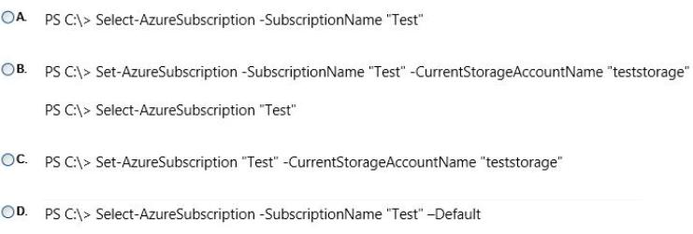

* A. Option A
* B. Option B
* C. Option C
* D. Option D

question_answerVIEW ANSWER

SHOW COMMENTS1

Answer : A

Explanation: Example: Set the current subscription This command makes Testthe current subscription. Windows PowerShell C:\PS> Select-AzureSubscription -SubscriptionName Test -Current References:

Question No : 20 -

You administer an Azure Storage account with a blob container. You enable Storage  
account logging for read, write and delete requests.  
You need to reduce the costs associated with storing the logs.  
What should you do?

* A. Execute Delete Blob requests over https.
* B. Create an export job for your container.
* C. Set up a retention policy.
* D. Execute Delete Blob requests over http.

question_answerVIEW ANSWER

SHOW COMMENTS0

Answer : C

Explanation: To ease the management of your logs, we have provided the functionality of retention policy which will automatically cleanup old logs without you being charged for the cleanup. It is recommended that you set a retention policy for logs such that your analytics data will be within the 20TB limit allowed for analytics data (logs and metrics combined). References:

Question No : 21 -

You manage a cloud service that has a web role named fabWeb. You create a virtual  
network named fabVNet that has two subnets defined as Web and Apps.  
You need to be able to deploy fabWeb into the Web subnet.  
What should you do?

* A. Modify the service definition (csdef) for the cloud service.
* B. Run the Set-AzureSubnet PowerShell cmdlet.
* C. Run the Set-AzureVNetConfig PowerShell cmdlet.
* D. Modify the network configuration file.
* E. Modify the service configuration (cscfg) for the fabWeb web role.

question_answerVIEW ANSWER

SHOW COMMENTS15

Answer : A

Explanation: Azure Service Definition Schema (.csdef File) The service definition file defines the service model for an application. The file contains the definitions for the roles that are available to a cloud service, specifies the service endpoints, and establishes configuration settings for the service.

Question No : 22 -

For development purposes, you deploy several virtual machines in an Azure subscription.  
Developers report that the virtual machines fail to access each other.  
You export the virtual network configuration for the subscription as shown in the following  
output.

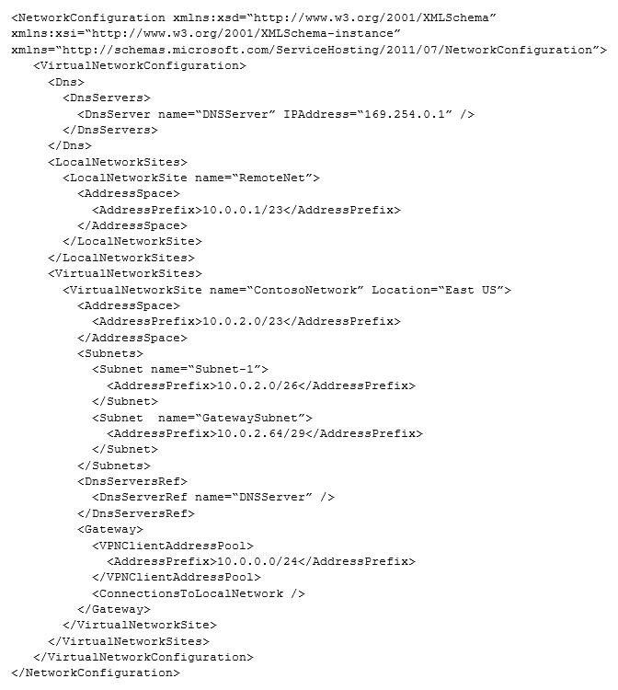

You need to modify the network configuration to resolve the connection issue.  
What should you modify?

* A. the IP address range of Subnet-1
* B. the IP address range of the gateway subnet. the IP address of the DNS server
* C. the site of the virtual network

question_answerVIEW ANSWER

SHOW COMMENTS3

Answer : C

Question No : 23 -

You administer an Azure Storage account named contosostorage. The account has a blob  
container to store image files.  
A user reports being unable to access an image file.  
You need to ensure that anonymous users can successfully read image files from the  
container.  
Which log entry should you use to verify access?



* A. Option A
* B. Option B
* C. Option C
* D. Option D

question_answerVIEW ANSWER

SHOW COMMENTS0

Answer : A

Explanation: Check for GetBlob and for AnonymousSuccess. Example: Get Blob AnonymousSuccess: 1.0;2011-07- 28T18:52:40.9241789Z;GetBlob;AnonymousSuccess;200;18;10;anonymous;;sally;blob;"htt p:// sally.blob.core.windows.net/thumbnails/lake.jpg?timeout=30000";"/sally/thumbnails/lake.jpg ";a84aa705-8a85-48c5-b064-b43bd22979c3;0;123.100.2.10;2009-09- 19;252;0;265;100;0;;;"0x8CE1B6EA95033D5";Thursday, 28-Jul-11 18:52:40 GMT;;;;"7/28/2011 6:52:40 PM ba98eb12-700b-4d53-9230-33a3330571fc" Incorrect: Not C: Check for AnonymousSuccess not Access. Not B, not D: Check for GetBlob not GetBlobProperties References:

Question No : 24 -

You manage an Azure virtual network that hosts 15 virtual machines (VMs) on a single  
subnet, which is used for testing a line of business (LOB) application. The application is  
deployed to a VM named TestWebServiceVM.  
You need to ensure that TestWebServiceVM always starts by using the same IP address.  
You need to achieve this goal by using the least amount of administrative effort.  
What should you do?

* A. Use the Management Portal to configure TestWebServiceVM.
* B. Use RDP to configure TestWebServiceVM.
* C. Run the Set-AzureStaticVNetIP PowerShell cmdlet.
* D. Run the Get-AzureReservedIP PowerShell cmdlet.

question_answerVIEW ANSWER

SHOW COMMENTS0

Answer : C

Explanation: Specify a static internal IP for a previously created VM If you want to set a static IP address for a VM that you previously created, you can do so by using the following cmdlets. If you already set an IP address for the VM and you want to change it to a different IP address, youll need to remove the existing static IP address before running these cmdlets. See the instructions below to remove a static IP. For this procedure, youll use the Update-AzureVM cmdlet. The Update-AzureVM cmdlet restarts the VM as part of the update process. The DIP that you specify will be assigned after the VM restarts. In this example, we set the IP address for VM2, which is located in cloud service StaticDemo. Get-AzureVM -ServiceName StaticDemo -Name VM2 | Set-AzureStaticVNetIP -IPAddress 192.168.4.7 | Update-AzureVM References:

Question No : 25 -

You have an Azure subscription.  
In Azure, you create two virtual machines named VM1 and VM2. Both virtual machines are  
instances in a cloud service named Cloud1.  
You need to ensure that the virtual machines only replicate within the data center in which  
they were created.  
Which settings should you modify?

* A. virtual machine
* B. storage account
* C. cloud services
* D. Azure subscription

question_answerVIEW ANSWER

SHOW COMMENTS8

Answer : B

##### Question No : 26 -

You manage an Azure subscription with virtual machines (VMs) that are running in  
Standard mode.  
You need to reduce the storage costs associated with the VMs.  
What should you do?

* **A.**Locate and remove orphaned disks.
* **B.**Add the VMs to an affinity group.
* **C.**Change VMs to the Basic tier.
* **D.**Delete the VHD container.

question_answerVIEW ANSWER

SHOW COMMENTS12

Answer : **C**

Explanation: Standard offers 50 GB of storage space, while Basic only gives 10 GB but it will save costs. References:

##### Question No : 27 -

Your development team has created a new solution that is deployed in a virtual network  
named fabDevVNet.  
Your testing team wants to begin testing the solution in a second Azure subscription.  
You need to create a virtual network named fabTestVNet that is identical to fabDevVNet.  
You want to achieve this goal by using the least amount of administrative effort.  
Which three steps should you perform in sequence? To answer, move the appropriate  
actions from the list of actions to the answer area and arrange them in the correct order.

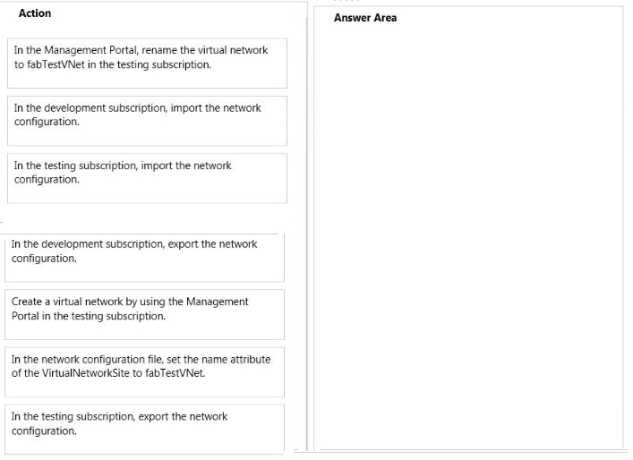

question_answerVIEW ANSWER

SHOW COMMENTS0

Answer :

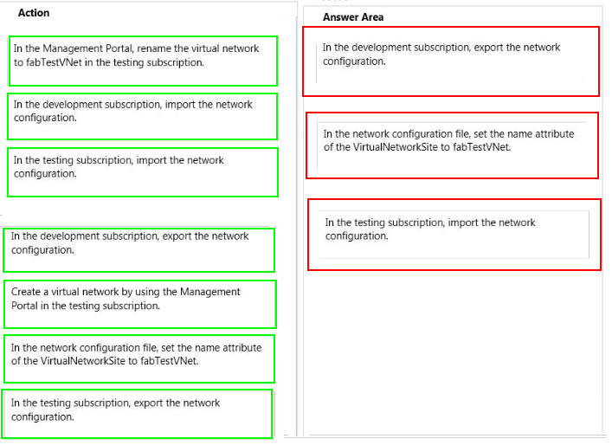

Explanation: Box 1:

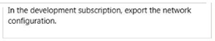

Box 2:

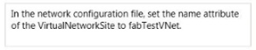

Box 3:

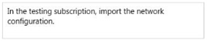

* You can export your network settings to a network configuration file (.xml). You can then use this file as a template to create additional virtual networks, or to recreate your virtual network if you delete it. * After youve configured your network configuration file, use the procedure below to import it into the Management Portal. To import a network configuration file: Log on to the Management Portal. In the navigation pane on the bottom left, click New. Click Network Services-> Virtual Network-> Import Configuration.

##### Question No : 28 -

You administer an Azure Virtual Machine (VM) named server1. The VM is in a cloud  
service named ContosoService1.  
You discover that the VM is experiencing storage issues due to increased application  
logging on the server.  
You need to create a new 256-GB disk and attach it to the server.  
Which Power Shell cmdlets should you use? To answer, drag the appropriate cmdlet to the  
correct location in the Power Shell command. Each cmdlet may be used once, more than  
once, or not at all. You may need to drag the split bar between panes or scroll to view  
content.

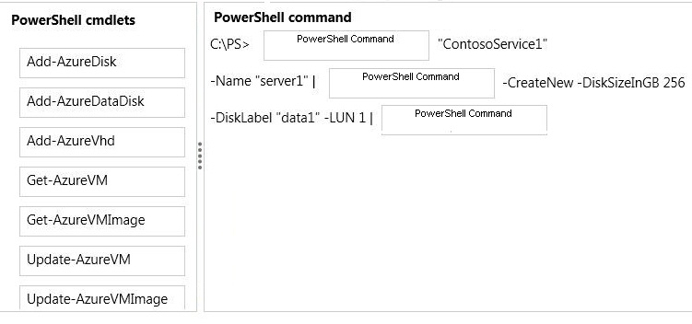

question_answerVIEW ANSWER

SHOW COMMENTS0

Answer :

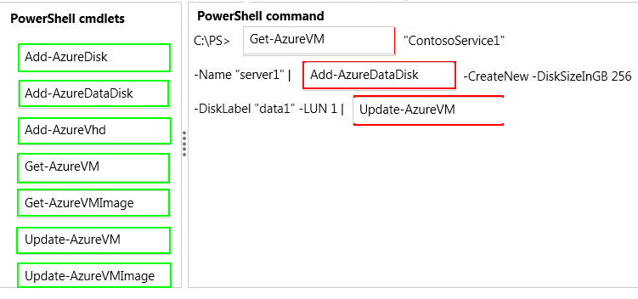

Explanation:

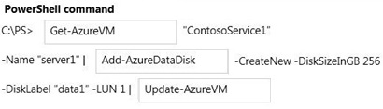

This example gets a virtual machine object for the virtual machine named MyVM in the myservice cloud service, updates the virtual machine object by attaching an existing data disk from the repository using the disk name, and then updates the Azure virtual machine. Windows PowerShell C:\PS>Get-AzureVM "myservice" -Name "MyVM" `| Add-AzureDataDisk -Import - DiskName "MyExistingDisk" -LUN 0 `| Update-AzureVM References:

##### Question No : 29 -

You manage an application hosted on cloud services. The development team creates a  
new version of the application. The updated application has been packaged and stored in  
an Azure Storage account.  
You have the following requirements:  
Which four steps should you perform in sequence? To answer, move the appropriate  
actions from the list of actions to the answer area and arrange them in the correct order.

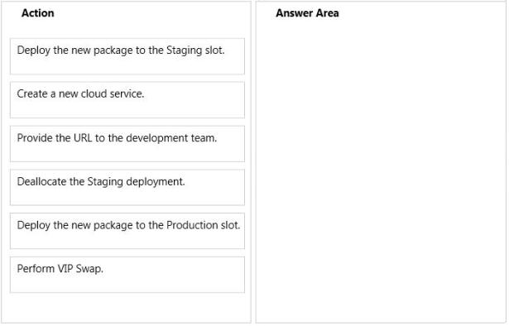

question_answerVIEW ANSWER

SHOW COMMENTS2

Answer :

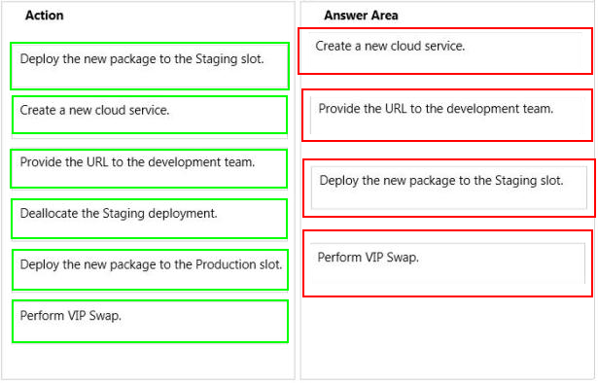

Explanation: Box 1: Create a new cloud service. Box 2: Provide the URL to the development team. Box 3: Deploy the new package to the Staging slot. Box 4: Perform VIP SWAP References:

##### Question No : 30 -

You create a Push Notification service by using an Azure Notification Hub.  
You need to monitor the Notification Hub programmatically.  
Which three actions should you perform in sequence? To answer, move the appropriate  
actions from the list of actions to the answer area and arrange them in the correct order.

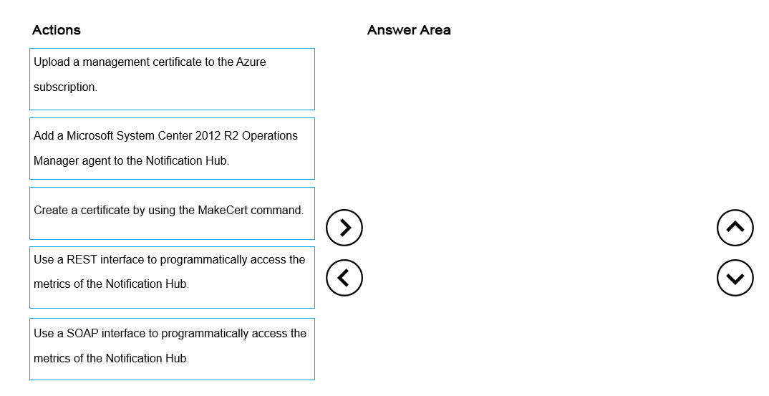

question_answerVIEW ANSWER

SHOW COMMENTS0

Answer :

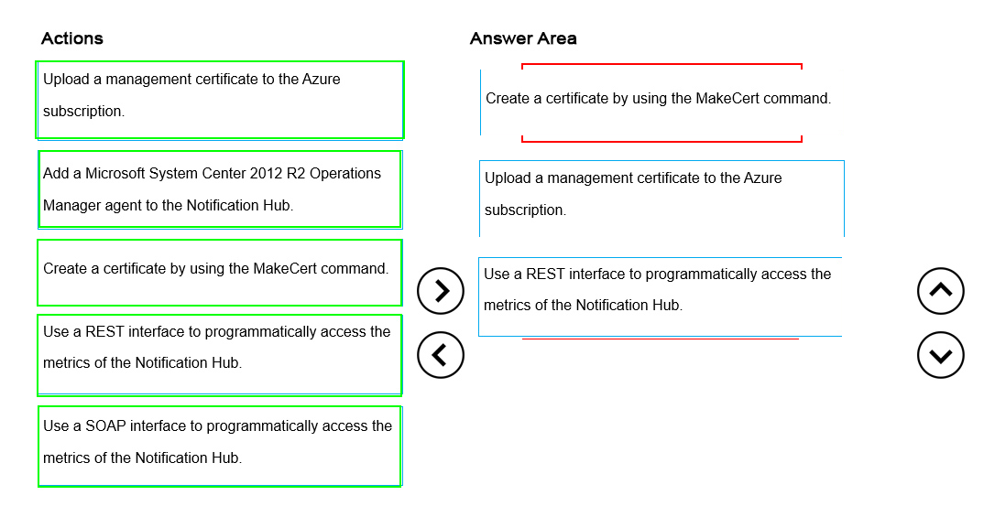

Explanation:

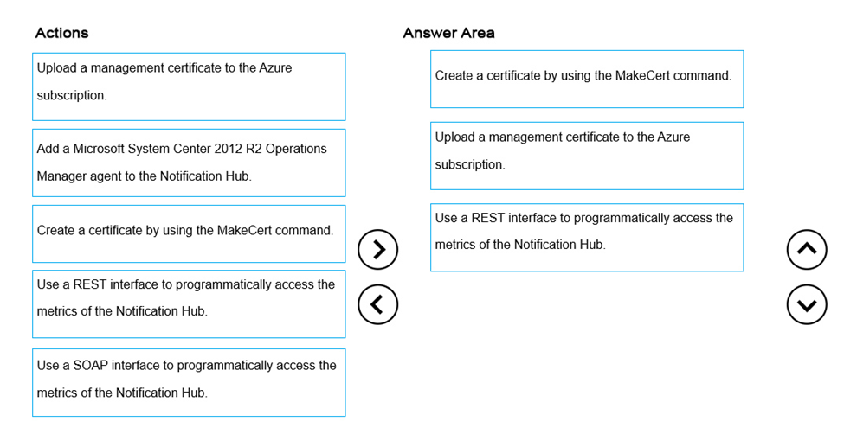

References: https://msdn.microsoft.com/en-us/library/azure/dn458823.aspx

##### Question No : 31 -

You have an Azure SQL Database named Contosodb. Contosodb is running in the  
Standard/S2 tier and has a service level objective of 99 percent.  
You review the service tiers in Microsoft Azure SQL Database as well as the results of  
running performance queries for the usage of the database for the past week as shown in  
the exhibits. (Click the Exhibits button.)

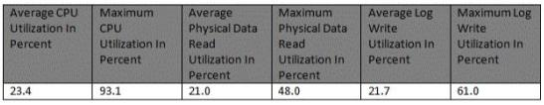



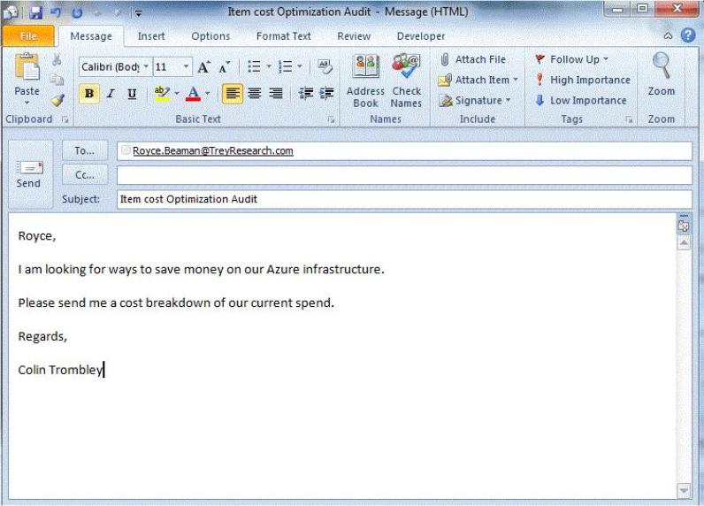

For each of the following statements, select Yes if the statement is true. Otherwise, select  
No.

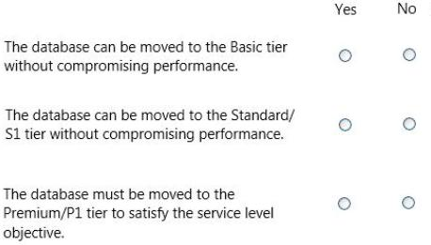

question_answerVIEW ANSWER

SHOW COMMENTS2

Answer :

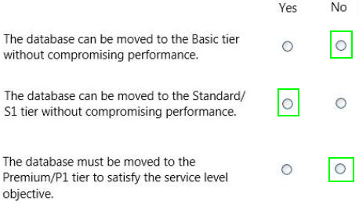

Explanation:

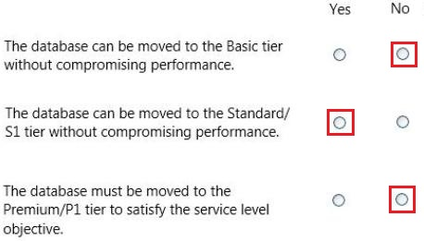

* The P1 performance level has 100 DTUs compared to the 200 DTUs of the P2 performance level. That means that the P1 performance level provides half the performance of the P2 performance level. So 50% of CPU utilization in P2 equals 100% CPU utilization in P1. As long as the application does not have timeouts, it may not matter if a big job takes 2 hours or 2.5 hours to complete as long as it gets done today. An application in this category can probably just use a P1 performance level. You can take advantage of the fact that there are periods of time during the day where resource usage is lower, meaning that any "big peak" might spill over into one of the

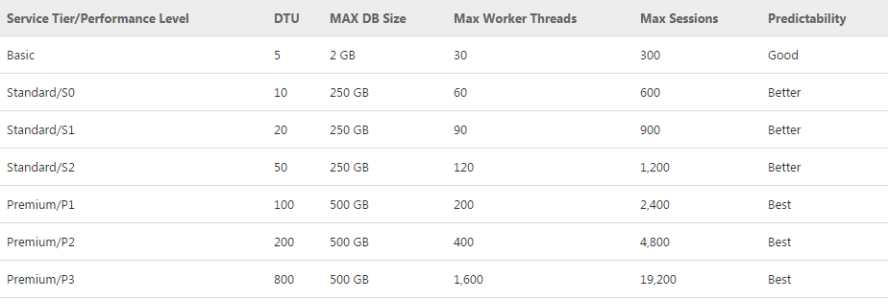

References:

##### Question No : 32 -

You manage a software-as-a-service application named SaasApp1 that provides user  
management features in a multi-directory environment.  
You plan to offer SaasApp1 to other organizations that use Azure Active Directory.  
You need to ensure that SaasApp1 can access directory objects.  
What should you do?

* **A.**Configure the Federation Metadata URL
* **B.**Register SaasApp1 as a native client application.
* **C.**Register SaasApp1 as a web application.
* **D.**Configure the Graph API.

question_answerVIEW ANSWER

SHOW COMMENTS0

Answer : **D**

Explanation: The Azure Active Directory Graph API provides programmatic access to Azure AD through REST API endpoints. Applications can use the Graph API to perform create, read, update, and delete (CRUD) operations on directory data and objects. For example, the Graph API supports the following common operations for a user object: / Create a new user in a directory / Get a users detailed properties, such as their groups / Update a users properties, such as their location and phone number, or change their password / Check a users group membership for role-based access / Disable a users account or delete it entirely References:

##### Question No : 33 -

You manage a large datacenter that has limited physical space.  
You plan to extend your datacenter to Azure.  
You need to create a connection that supports a multiprotocol label switching (MPLS)  
virtual private network.  
Which connection type should you use?

* **A.**Site-to-site
* **B.**VNet-VNet
* **C.**ExpressRoute.
* **D.**Site-to-peer

question_answerVIEW ANSWER

SHOW COMMENTS8

Answer : **C**

Explanation: ExpressRoute allows you to securely add compute and storage capacity to your existing datacenter. With high throughput and fast latencies, Azure will feel like a natural extension to your datacenter so you enjoy the scale and economics of the public cloud without having to compromise on network performance. References:

##### Question No : 34 -

You manage a cloud service that supports features hosted by two instances of an Azure  
virtual machine (VM).  
You discover that occasional outages cause your service to fail.  
You need to minimize the impact of outages to your cloud service.  
Which two actions should you perform? Each correct answer presents part of the solution.

* **A.**Deploy a third instance of the VM.
* **B.**Configure Load Balancing on the VMs.
* **C.**Redeploy the VMs to belong to an Affinity Group.
* **D.**Configure the VMs to belong to an Availability Set.

question_answerVIEW ANSWER

SHOW COMMENTS10

Answer : **A,B**

##### Question No : 35 -

You manage an Azure virtual machine (VM) named AppVM. The application hosted on  
AppVM continuously writes small files to disk. Recently the usage of applications on  
AppVM has increased greatly.  
You need to improve disk performance on AppVM.  
Which Microsoft Azure Power Shell cmdlet should you use with each Power Shell  
command line? To answer, drag the appropriate Microsoft Azure Power Shell cmdlet to the  
correct location in the Power Shell code. Each Power Shell cmdlet may be used once,  
more than once, or not at all. You may need to drag the split bar between panes or scroll to  
view content.

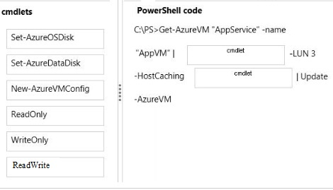

question_answerVIEW ANSWER

SHOW COMMENTS3

Answer :

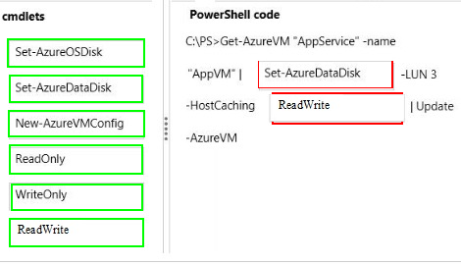

Explanation: Box 1: Set-AzureDataDisk Box 2: ReadWrite * Set-AzureDataDisk Sets the host-cache mode on an existing data disk object. * Example: This command gets the "MyVM" virtual machine running on the "myservice" cloud service, and then sets the data disk at LUN 2 of the virtual machine to use ReadOnly host caching. Windows PowerShell C:\PS>Get-AzureVM "myservice" -name "MyVM" | Set-AzureDataDisk -LUN 2 - HostCaching ReadOnly | Update-AzureVM * Set-AzureDataDisk Parameter: -HostCaching<String> Sets the host level caching settings of the disk. Possible values are: None, ReadOnly and ReadWrite (WriteOnly is NOT an option). References:

##### Question No : 36 -

You administer an Azure subscription with an existing cloud service named  
contosocloudservice. Contosocloudservice contains a set of related virtual machines (VMs)  
named ContosoDC, ContosoSQL and ContosoWeb1.  
You want to provision a new VM within contosocloudservice.  
You need to use the latest gallery image to create a new Windows Server 2012 R2 VM that  
has a target IOPS of 500 for any provisioned disks.  
Which PowerShell command should you use?

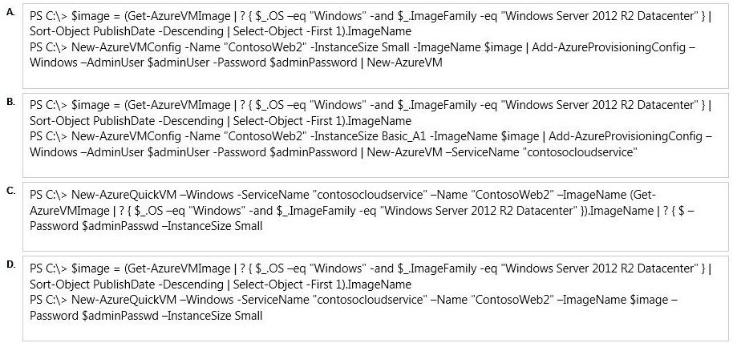

* **A.**Option A
* **B.**Option B
* **C.**Option C
* **D.**Option D

question_answerVIEW ANSWER

SHOW COMMENTS14

Answer : **B**

Explanation: We must use the ServiceName parameter as the new VM is to be provisioned within an existing service. New-AzureVM -ServiceName -ServiceName<String> specifies the new or existing service name. References:

##### Question No : 37 -

Your company manages several Azure Web Sites that are running in an existing web-  
hosting plan named plan1.  
You need to move one of the websites, named contoso, to a new web-hosting plan named  
plan2.  
Which Azure PowerShell cmdlet should you use with each PowerShell command line? To  
answer, drag the appropriate Azure PowerShell cmdlet to the correct location in the  
PowerShell code. Each PowerShell cmdlet may be used once, more than once, or not at  
all. You may need to drag the split bar between panes or scroll to view content.

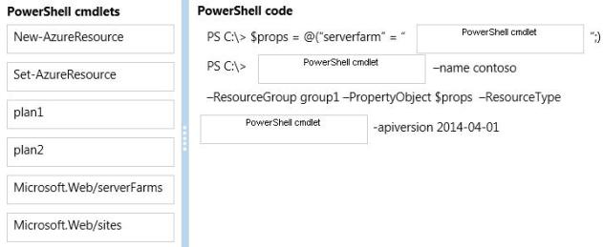

question_answerVIEW ANSWER

SHOW COMMENTS0

Answer :

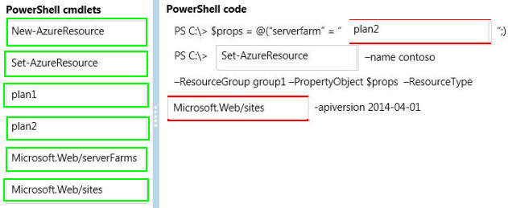

Explanation:

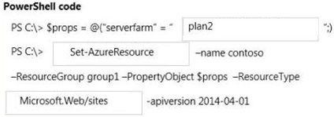

Example: The following command is actually a series of commands (delimited by semi-colons) that change the values of the properties in the $p variable. Windows PowerShell PS C:\> $p.siteMode = "Basic"; $p.sku = "Basic"; $p.computeMode = "Dedicated"; $p.serverFarm = "Default2" The next command uses the Set-AzureResource cmdlet to change the change the properties of the ContosoLabWeb2 web site. The value of the PropertyObject parameter is the $p variable that contains the Properties object and the new values. The command saves the output (the updated resource) in the $r2 variable. Windows PowerShell PS C:\> $r2 = Set-AzureResource -Name ContosoLabWeb2 -ResourceGroupName ContosoLabsRG -ResourceType "Microsoft.Web/sites" -ApiVersion 2004-04-01 - PropertyObject $p

##### Question No : 38 -

You create a virtual network named fabVNet01.  
You design the virtual network to include two subnets, one named DNS-subnet and one  
named Apps-subnet, as shown in the exhibit. (Click the Exhibits button.)

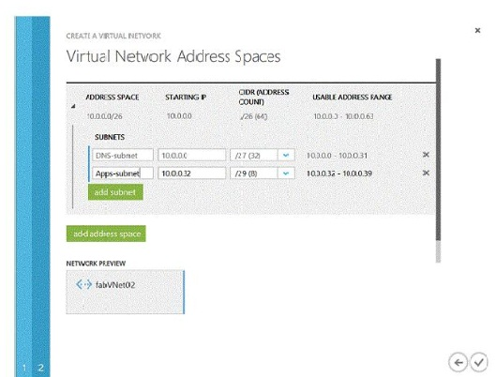

In the table below, identify the number of IP addresses that will be available for virtual  
machines (VMs) or cloud services in each subnet. Make only one selection in each column.

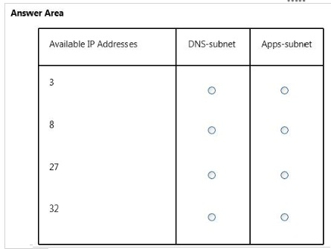

question_answerVIEW ANSWER

SHOW COMMENTS11

Answer :

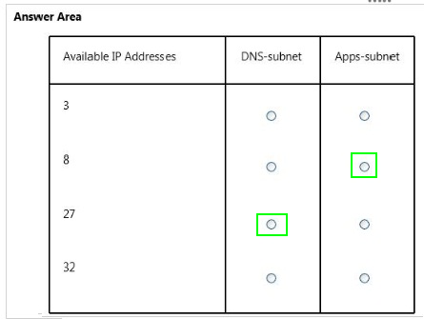

Explanation:

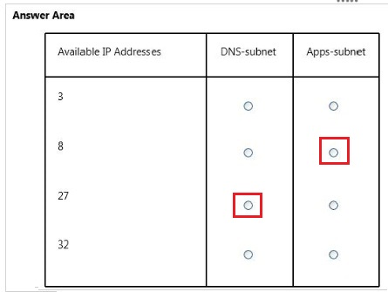

References:

##### Question No : 39 -

You manage an Azure Web Site named contosoweb. Logging is enabled for contosoweb.  
You need to view only errors from your log files in a continuous stream as they occur.  
Which Windows Power Shell command should you execute?

* **A.**Get-AzureWebSiteLog -Name contosoweb -OutBuffer Error
* **B.**Save-AzureWebSiteLog -Name contosoweb -Output Errors
* **C.**Get-AzureWebSiteLog -Name contosoweb -Tail –Message Error
* **D.**Get-Azure WebSiteLog -Name contosoweb -Message Error

question_answerVIEW ANSWER

SHOW COMMENTS1

Answer : **C**

Explanation: Example This example starts log streaming and show error logs only. Windows PowerShell C:\PS>Get-AzureWebsiteLog -Tail -Message Error References:

##### Question No : 40 -

You are the server administrator for several on-premises systems.  
You need to back up all the systems to the cloud by using Azure Backup.  
In which order should you perform the actions? To answer, move all actions from the list of  
actions to the answer area and arrange them in the correct order.

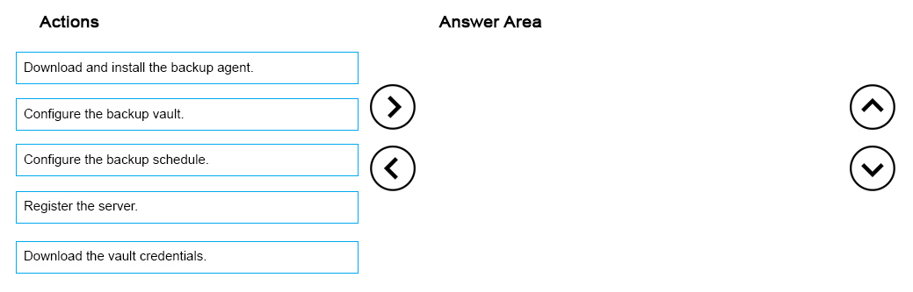

question_answerVIEW ANSWER

SHOW COMMENTS6

Answer :

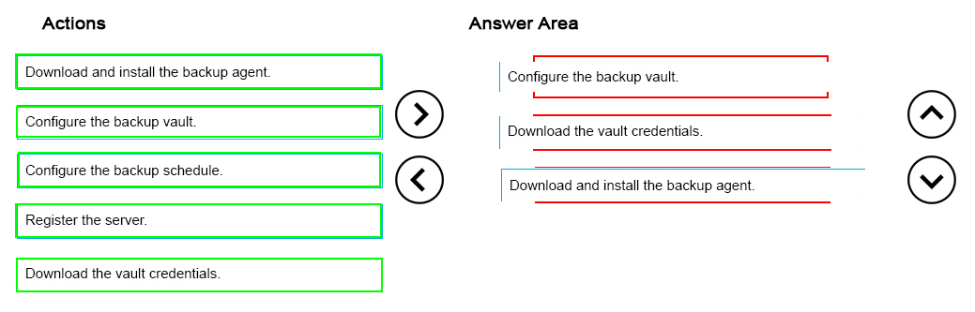

Explanation:

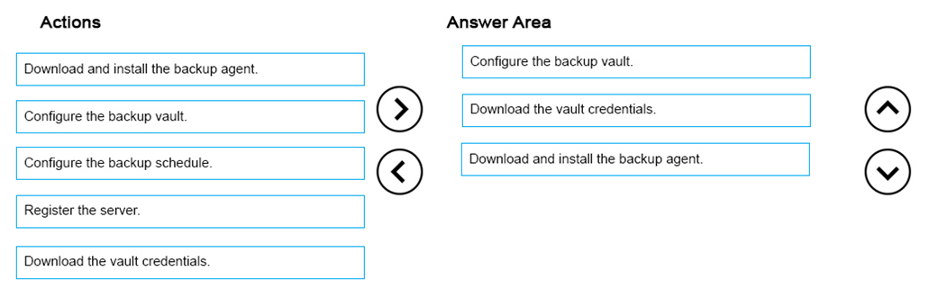

##### Question No : 41 -

Your company plans to migrate from On-Premises Exchange to Office 365.  
The existing directory has numerous service accounts in your On-Premises Windows  
Active Directory (AD), stored in separate AD Organizational Units (OU) for user accounts.  
You need to prevent the service accounts in Windows AD from syncing with Azure AD.  
What should you do?

* **A.**Create an OU filter in the Azure AD Module for Windows PowerShell.
* **B.**Configure directory partitions in miisclient.exe.
* **C.**Set Active Directory ACLs to deny the DirSync Windows AD service account MSOL_AD_SYNC access to the service account OUs.
* **D.**Create an OU filter in the Azure Management Portal.

question_answerVIEW ANSWER

SHOW COMMENTS7

Answer : **B**

Explanation: One customer, who was looking for OU level filtering to import selected users from On- Premises active directory to Office365. Configure OU level filtering for Office365 directory synchronization.

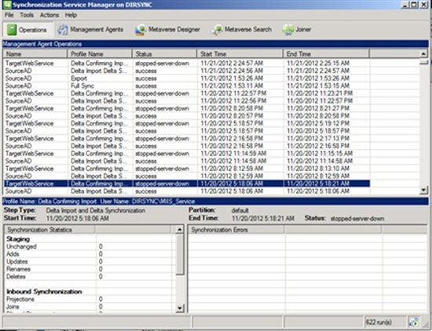

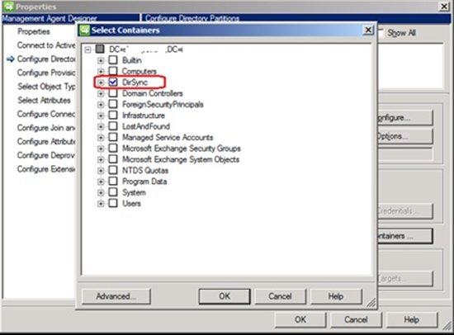

Etc. References:

##### Question No : 42 -

An organization has several web applications and uses Azure Active Directory (Azure AD).  
You are developing a new web application that supports sign-on using the WS-Federation  
to Azure AD.  
You need to describe the authentication process flow to your team.  
In which order are the actions performed? To answer, move all actions from the list of  
actions to the answer area and arrange them in the correct order.

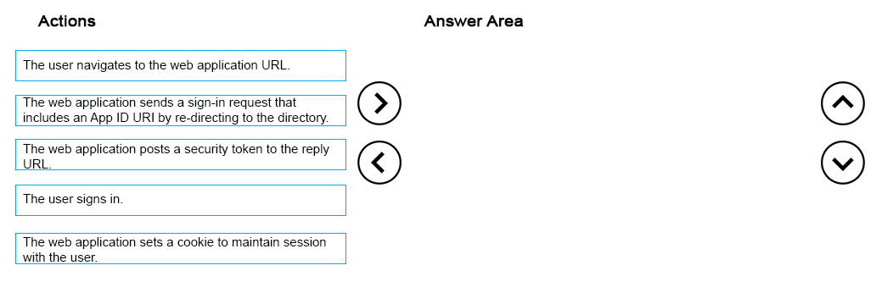

question_answerVIEW ANSWER

SHOW COMMENTS0

Answer :

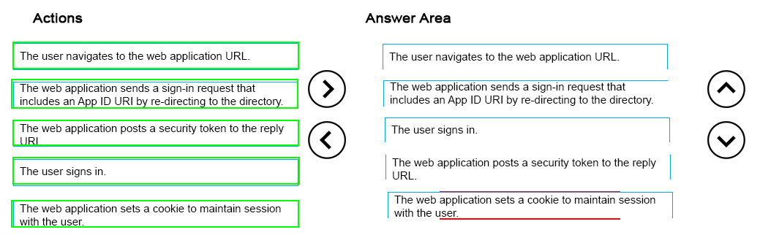

Explanation:

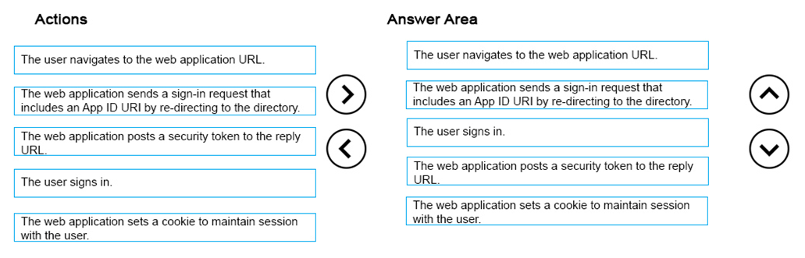

References: https://azure.microsoft.com/en-gb/documentation/articles/active-directory-authentication- scenarios/

##### Question No : 43 -

Your company has two physical locations configured in a geo-clustered environment that  
includes:  
Your company has recently signed up for Azure.  
You plan to leverage your current network environment to provide a backup solution for  
your VMs.  
You need to recommend a solution that ensures all VMs are redundant and deployable  
between locations. You also want the solution to minimize downtime in the event of an  
outage at either physical location.  
Which solution should you recommend?

* **A.**Configure a backup vault in Azure and use Data Protection Manager to back up The Windows Servers.
* **B.**Use Data Protection Manager and back up the VMs in each location.
* **C.**Use Azure site recovery in an on-premises to Azure protection configuration.
* **D.**Use Azure site recovery in an on-premises to on-premises protection configuration.

question_answerVIEW ANSWER

SHOW COMMENTS1

Answer : **D**

Explanation: On-Premises to On-Premises (Hyper-V replication) * Cloud metadata is sent to Azure Site Recovery. Replicated data is stored in location specified on target Hyper-V server. * Azure account with Azure Site Recovery enabled. * Virtual machines replicate from source on-premises Hyper-V server to another. You can set up reverse replication to replicate back to the source location. * Requires source and target VMM servers with at least one cloud on each, or a single VMM server with two clouds. Clouds must contain at least one Hyper-V host server or cluster. References:

##### Question No : 44 -

You manage a cloud service named fabrikamReports that is deployed in an Azure data  
center.  
You deploy a virtual machine (VM) named fabrikamSQL into a virtual network named  
fabrikamVNet.  
FabrikamReports must communicate with fabrikamSQL.  
You need to add fabrikam Reports to fabrikamVNet.  
Which file should you modify?

* **A.**the network configuration file for fabrikamVNet
* **B.**the service definition file (.csdef) for fabrikamReports
* **C.**the service definition file (.csdef) for fabrikamSQL
* **D.**the service configuration file (.cscfg) for fabrikamReports
* **E.**the service configuration file (.cscfg) fabrikamSQL

question_answerVIEW ANSWER

SHOW COMMENTS5

Answer : **B**

Explanation: Azure Service Definition Schema (.csdef File) The service definition file defines the service model for an application. The file contains the definitions for the roles that are available to a cloud service, specifies the service endpoints, and establishes configuration settings for the service. References:

##### Question No : 45 -

You have a virtual machine (VM) that runs in Azure. The VM is located in a geographically  
distant location from you.  
You experience performance issues when you connect to the VM.  
You need to resolve the performance issue.  
Which four actions should you perform in sequence? To answer, move the appropriate  
actions from the list of actions to the answer area and arrange them in the correct order.

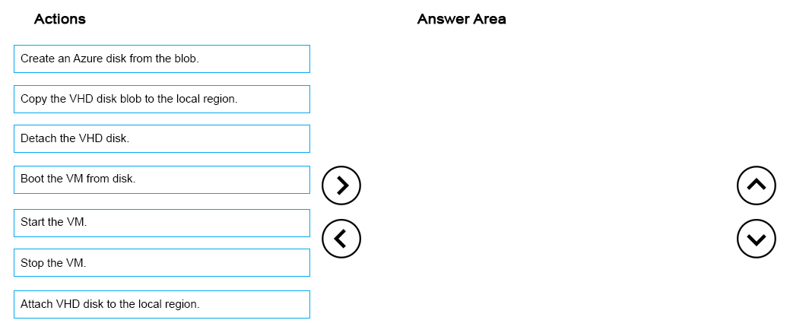

question_answerVIEW ANSWER

SHOW COMMENTS0

Answer :

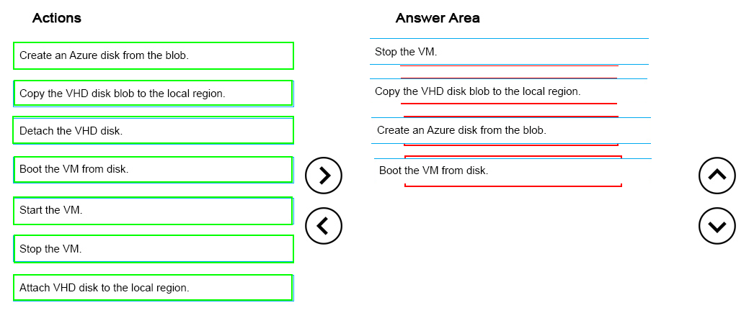

##### Question No : 46 -

You deploy a web application to an Azure Cloud Service. The application uses a storage  
account that contains a large number of storage objects.  
You need to grant clients access to application data for a specified interval of time while  
minimizing effort.  
What should you create?

* **A.**a stored access policy
* **B.**a service shared access signature
* **C.**an account shared access signature
* **D.**a network security group

question_answerVIEW ANSWER

SHOW COMMENTS10

Answer : **C**

Explanation: References: https://azure.microsoft.com/en-gb/documentation/articles/storage-dotnet-shared-access- signature-part-1/

##### Question No : 47 -

You administer a virtual machine (VM) that is deployed to Azure. The VM hosts a web  
service that is used by several applications.  
You need to ensure that the VM sends a notification in the event that the average response  
time for the web service exceeds a pre-defined response time for an hour or more.  
Which three steps should you perform in sequence? To answer, move the appropriate  
actions from the list of actions to the answer area and arrange them in the correct order.

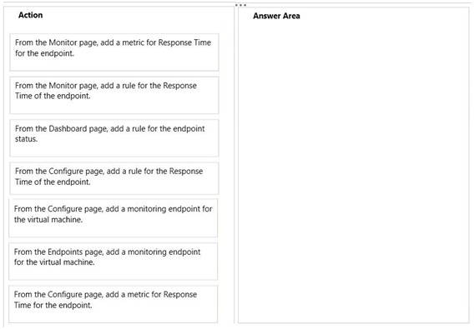

question_answerVIEW ANSWER

SHOW COMMENTS3

Answer :

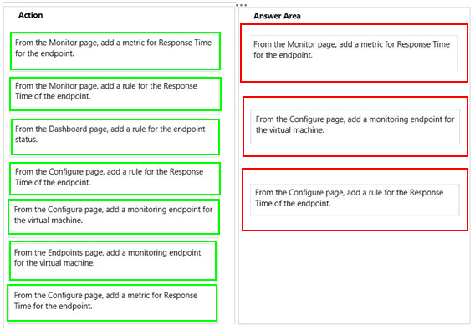

Explanation: Box 1:

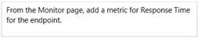

Box 2:

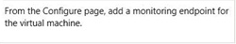

Box 3:

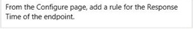

* (Step 1). First we must add a metric. * (Step 2) To configure endpoint monitoring: * (Step 3). In Standard website mode, you can receive alerts based on your website monitoring metrics. The alert feature requires that you first configure a web endpoint for monitoring, which you can do in the Monitoring section of the Configure page. On theSettings page of the Azure Management Portal, you can then create a rule to trigger an alert when the metric you choose reaches a value that you specify. References:

##### Question No : 48 -

You manage an Azure Web Site named contososite.  
You download the subscription publishing credentials named Contoso-  
Enterprise.publishsettings.  
You need to use Azure Power Shell to achieve the following:  
Which commands should you use? To answer, drag the appropriate Azure PowerShell  
command to the correct location in the solution. Each command may be used once, more  
than once, or not at all. You may need to drag the split bar between panes or scroll to view  
content.

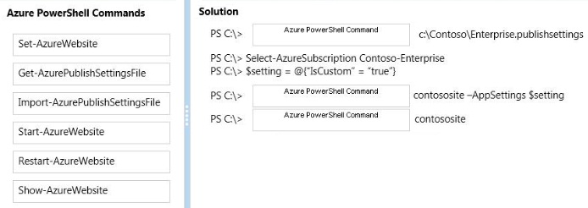

question_answerVIEW ANSWER

SHOW COMMENTS2

Answer :

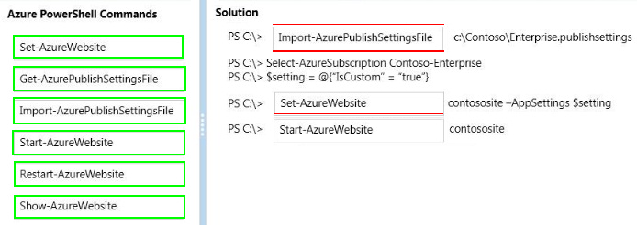

Explanation:

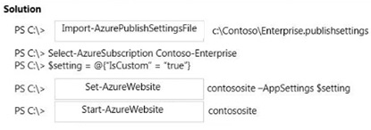

References:

##### Question No : 49 -

You manage several Azure virtual machines (VMs). You create a custom image to be used  
by employees on the development team.  
You need to ensure that the custom image is available when you deploy new servers.  
Which Azure Power Shell cmdlet should you use?

* **A.**Update-AzureVMImage
* **B.**Add-AzureVhd
* **C.**Add-AzureVMImage
* **D.**Update-AzureDisk
* **E.**Add-AzureDataDisk

question_answerVIEW ANSWER

SHOW COMMENTS0

Answer : **C**

Explanation: The Add-AzureVMImage cmdlet adds an operating system image to the image repository. The image should be a generalized operating system image, using either Sysprep for Windows or, for Linux, using the appropriate tool for the distribution. Example This example adds an operating system image to the repository. Windows PowerShell C:\PS>Add-AzureVMImage -ImageName imageName -MediaLocation http://yourstorageaccount.blob.core.azure.com/container/sampleImage.vhd -Label References:

##### Question No : 50 -

You have an Azure Virtual Network named fabVNet with three subnets named Subnet-1,  
Subnet-2 and Subnet-3. You have a virtual machine (VM) named fabVM running in the  
fabProd service.  
You need to modify fabVM to be deployed into Subnet-3. You want to achieve this goal by  
using the least amount of time and while causing the least amount of disruption to the  
existing deployment.  
What should you do? To answer, drag the appropriate Power Shell cmdlet to the correct  
location in the Power Shell command. Each cmdlet may be used once, more than once, or  
not at all. You may need to drag the split bar between panes or scroll to view content.

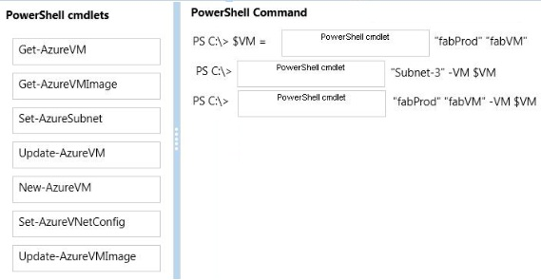

question_answerVIEW ANSWER

SHOW COMMENTS0

Answer :

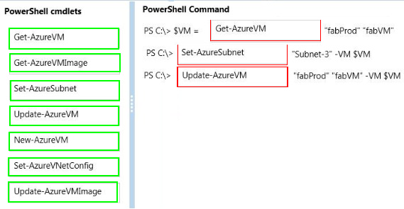

Explanation:

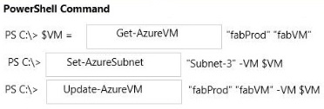

Example -------------- This example changes the size of the virtual machine "MyVM3", running in "MySvc1", to "Medium". Windows PowerShell C:\PS>Get-AzureVM -ServiceName "MySvc1" -Name "MyVM3" `| Set-AzureVMSize InstanceSize "Medium" `| Update-AzureVM References:

##### Question No : 51 -

You have a solution deployed into a virtual network in Azure named fabVNet. The fabVNet  
virtual network has three subnets named Apps, Web, and DB that are configured as shown  
in the exhibit. (Click the Exhibits button.)

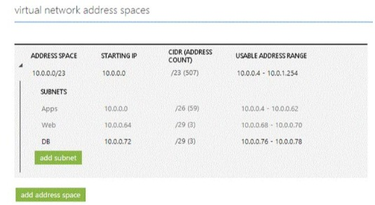

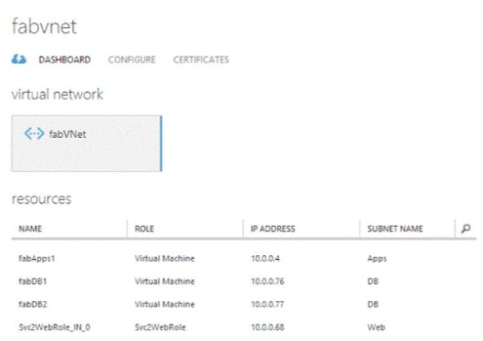

You want to deploy two new VMs to the DB subnet.  
You need to modify the virtual network to expand the size of the DB subnet to allow more  
IP addresses.  
Which three steps should you perform in sequence? To answer, move the appropriate  
actions from the list of actions to the answer area and arrange them in the correct order.

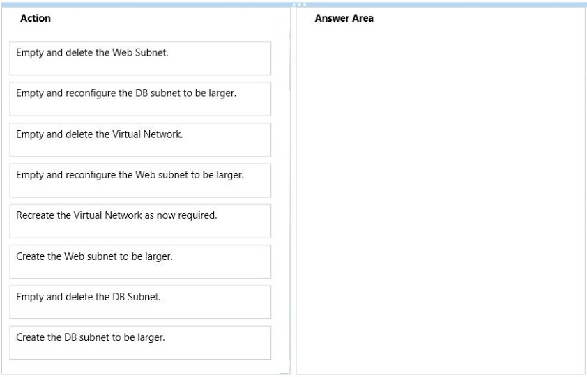

question_answerVIEW ANSWER

SHOW COMMENTS8

Answer :

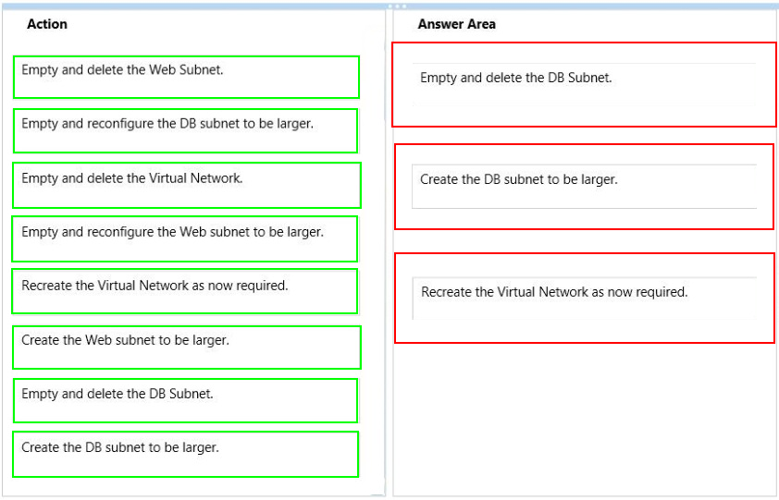

Explanation: Box 1: Empty and delete the DB Subnet. Box 2: Create the DB subnet to be larger. Box 3: Recreate the Virtual Network as now required. Note (which seems to indicate that only two steps would be required): * Q: Can I modify my virtual network size after I created them? A: You can add, remove, expand or shrink a subnet if there are no VMs or services deployed within it by using PowerShell cmdlets or the NETCFG file. * Q: Can I modify subnets after I created them? A: You can modify the subnet addresses as long as there are no services or VMs deployed within them by using PowerShell cmdlets or the NETCFG file. You cannot modify or delete a subnet once services or VMs have been deployed to it. References:

##### Question No : 52 -

You manage a cloud service that has a web application named WebRole1. WebRole1  
writes error messages to the Windows Event Log.  
Users report receiving an error page with the following message: "Event 26 has occurred.  
Contact your system administrator."  
You need to access the WebRole1 event log.  
Which three actions should you perform? Each correct answer presents part of the  
solution.

* **A.**Enable verbose monitoring.
* **B.**Update the WebRole1 web.config file.
* **C.**Update the cloud service definition file and the service configuration file.
* **D.**Run the Set-AzureVMDiagnosticsExtension PowerShell cmdlet.
* **E.**Run the Enable-AzureWebsiteApplicationDiagnostic PowerShell cmdlet.
* **F.**Create a storage account.

question_answerVIEW ANSWER

SHOW COMMENTS2

Answer : **B,C,E**

##### Question No : 53 -

You have an Azure subscription that has five virtual machines (VMs). You provision the  
VMs in an availability set to support an existing web service.  
You anticipate additional traffic. You identify the following additional requirements for the  
VMs:  
You need to scale the service.  
What should you recommend?

* **A.**P10 Premium Storage. P20 Premium Storage
* **B.**a Basic Tier VM
* **C.**a Standard Tier VM

question_answerVIEW ANSWER

SHOW COMMENTS8

Answer : **B**

Explanation: References: https://azure.microsoft.com/en-gb/documentation/articles/storage-premium- storage/#premium-storage-scalability-and-performance-targets

##### Question No : 54 -

You have a virtual network and virtual machines that use the Resource Manager  
deployment model.  
You plan to create a Network Security Group (NSG). You must apply rules to both inbound  
and outbound traffic.  
You need to create the NSG.  
In which order will the rules be applied to the virtual network? To answer, drag the  
appropriate option to the correct location. Each option may be used once, more than once,  
or not at all. You may need to drag the split bar between panes or scroll to view content.

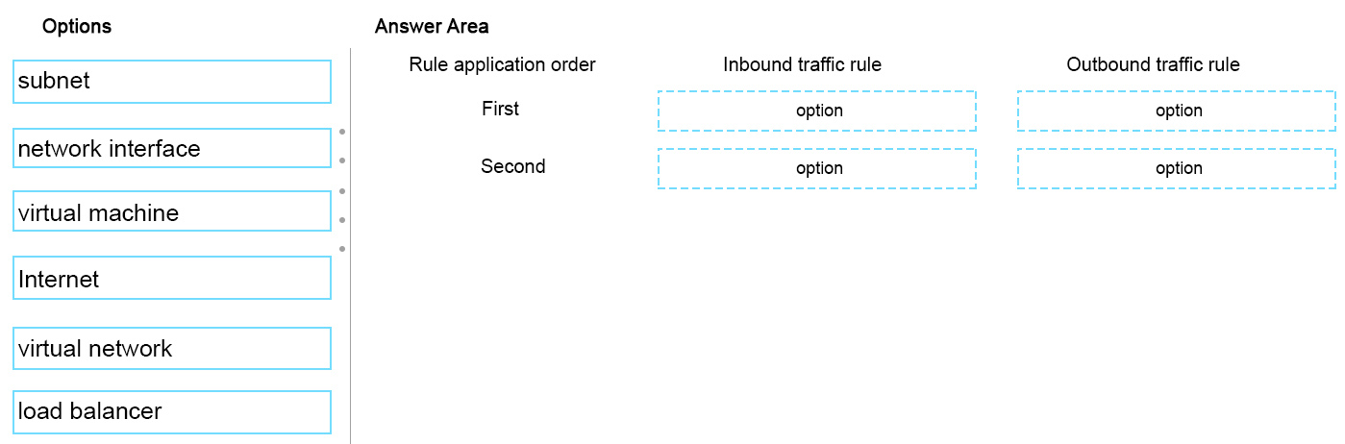

question_answerVIEW ANSWER

SHOW COMMENTS0

Answer :

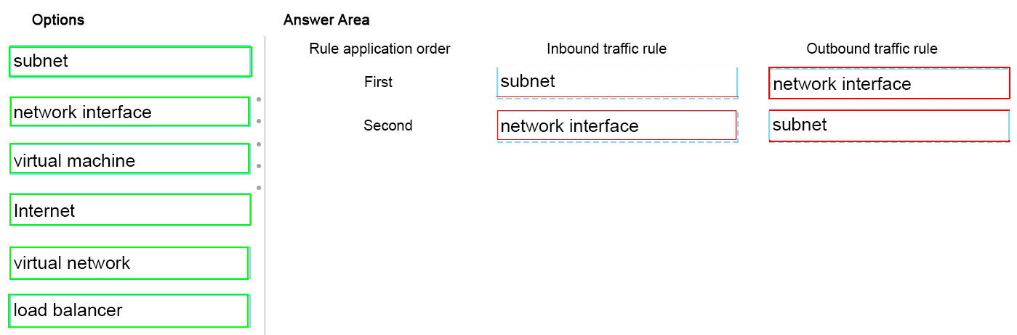

Explanation:

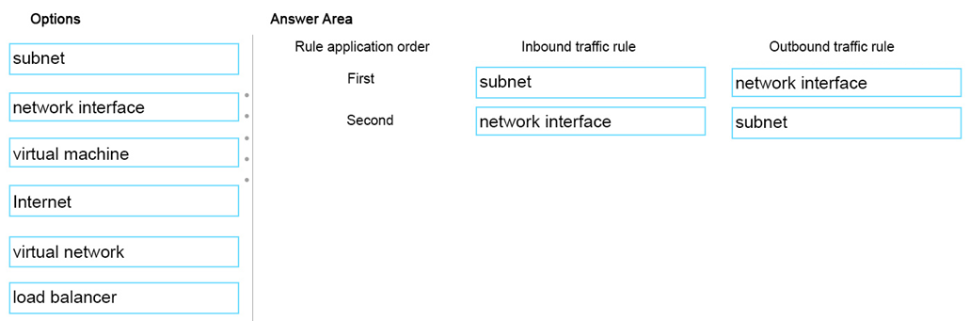

References: https://azure.microsoft.com/en-gb/documentation/articles/virtual-networks-nsg/

##### Question No : 55 -

You manage an Azure virtual network that hosts 15 virtual machines (VMs) on a single  
subnet, which is used for testing a line of business (LOB) application. The application is  
deployed to a VM named TestWebServiceVM.  
You need to ensure that TestWebServiceVM always starts by using the same IP address.  
You need to achieve this goal by using the least amount of administrative effort.  
What are two possible ways to achieve the goal? Each correct answer presents a complete  
solution.

* **A.**Run the following Azure PowerShell cmdlet:Set-AzureStaticVNetIP
* **B.**Use the Azure portal to configure TestWebServiceVM.
* **C.**Run the following Azure PowerShell cmdlet:Get-AzureReservedIP
* **D.**Use RDP to configure TestWebServiceVM.

question_answerVIEW ANSWER

SHOW COMMENTS1

Answer : **A,B**

##### Question No : 56 -

You have an Azure subscription that contains a backup vault named BV1. BV1 contains  
five protected servers. Backups run daily. You need to modify the storage replication  
settings for the backups.  
What should you do first?

* **A.**Create a new backup vault.
* **B.**Run the Remove-OBPolicy cmdlet.. Configure the backup agent properties on all five servers.
* **C.**Run the Remove-OBFileSpec cmdlet.

question_answerVIEW ANSWER

SHOW COMMENTS2

Answer : **C**

Explanation: References: https://azure.microsoft.com/en-gb/documentation/articles/backup-azure-backup-cloud-as- tape/

##### Question No : 57 -

You manage an Azure Web Site that is running in Shared mode.  
You discover that the website is experiencing increased average response time during  
periods of heavy user activity.  
You need to update the website configuration to address the performance issues as they  
occur.  
What should you do?

* **A.**Set the website to Standard mode and configure automatic scaling based on CPU utilization.
* **B.**Configure automatic seating during specific dates.
* **C.**Modify the website instance size.
* **D.**Configure automatic scaling based on memory utilization.
* **E.**Set the website to Basic mode and configure automatic scaling based on CPU utilization.

question_answerVIEW ANSWER

SHOW COMMENTS0

Answer : **A**

Explanation: Scaling to Standard Plan Mode Selecting Standard expands the Capacity section to reveal the Instance Size and Instance Count options, which are also available in Basic mode. The Edit Scale Settings for Schedule and Scale by Metric options are available only in Standard mode.

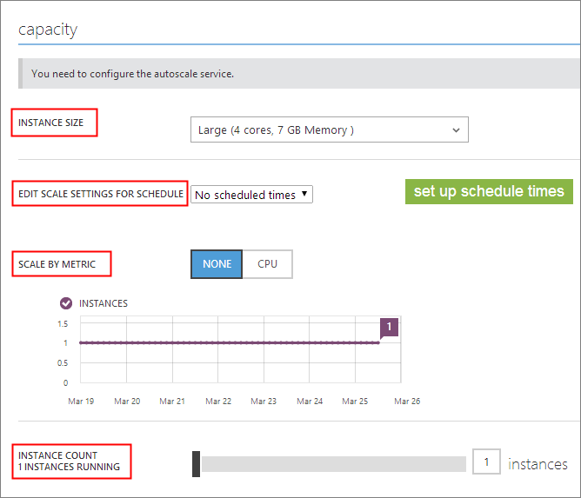

Note: References:

##### Question No : 58 -

You have an Azure subscription that contains two Azure SQL Database servers named  
lpqd0zbr8y and bk0b8kf65. lpqd0zbr8y contains a database named Orders.  
You need to implement active geo-replication for the Orders database.  
Which command should you run? To answer, select the appropriate options in the answer  
area.

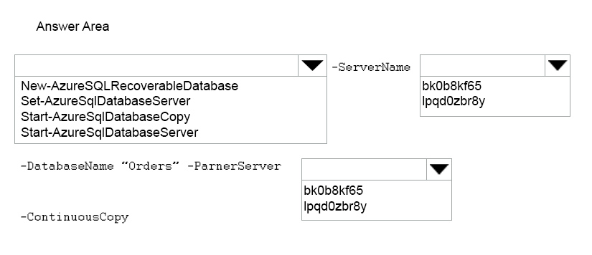

question_answerVIEW ANSWER

SHOW COMMENTS0

Answer :

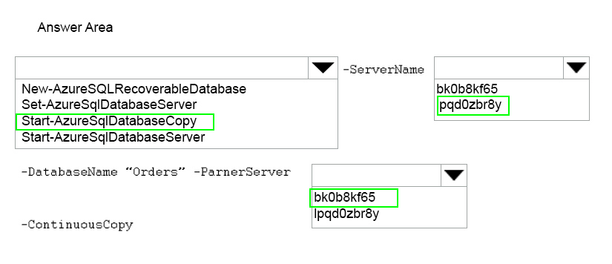

Explanation:

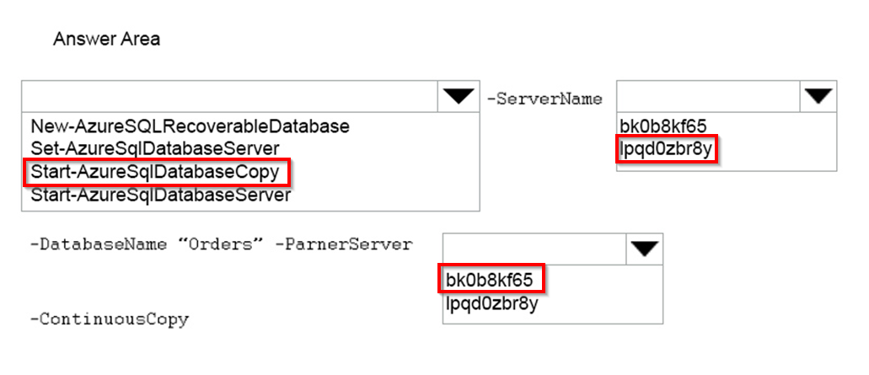

References: https://msdn.microsoft.com/en-us/library/dn720220.aspx

##### Question No : 59 -

You manage an Azure virtual network environment for a company that has an office in  
Boston. The company plans to open a new office location in Paris.  
You must replicate the Boston virtual network environment in Paris.  
How should you complete the relevant Azure PowerShell commands? To answer, drag the  
appropriate Azure PowerShell segment to the correct location. Each Azure PowerShell  
segment may be used once, more than once, or not at all. You may need to drag the split  
bar between panes or scroll to view content.

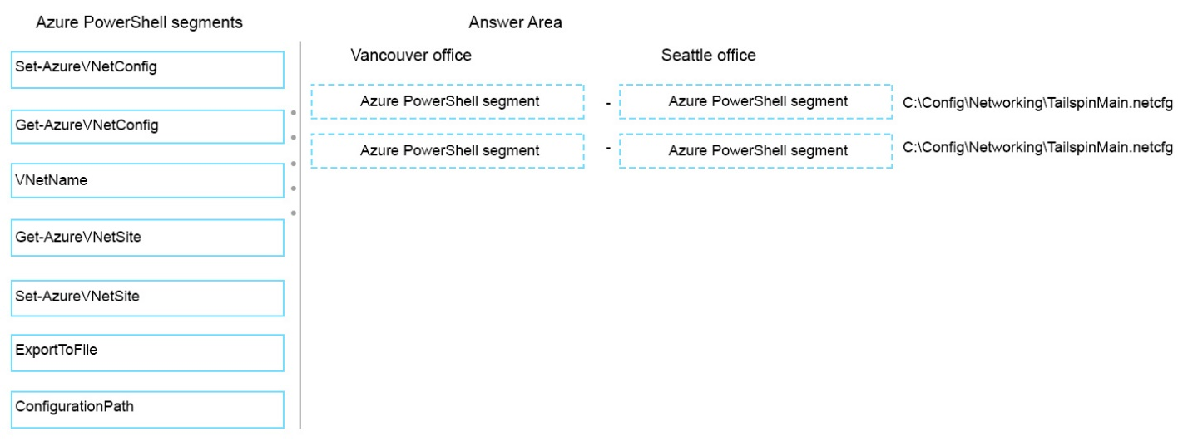

question_answerVIEW ANSWER

SHOW COMMENTS6

Answer :

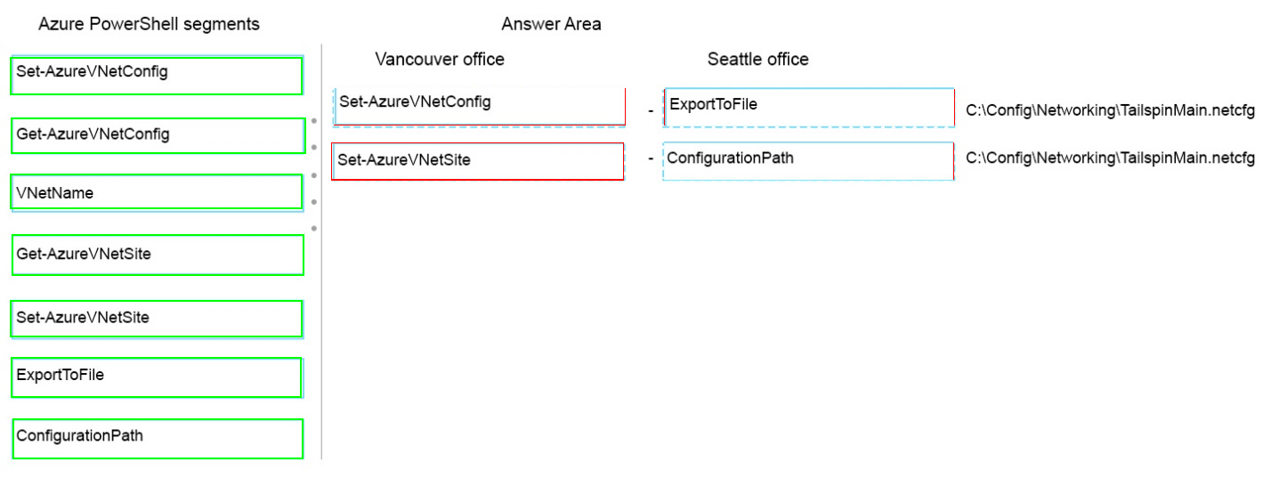

##### Question No : 60 -

Your company plans to migrate from On-Premises Exchange to Exchange Online in Office  
365.  
You plan to integrate your existing Active Directory Domain Services (AD DS) infrastructure  
with Azure AD.  
You need to ensure that users can log in by using their existing AD DS accounts and  
passwords. You need to achieve this goal by using minimal additional systems.  
Which two actions should you perform? Each answer presents part of the solution.

* **A.**Configure Password Sync.
* **B.**Set up a DirSync Server.
* **C.**Set up an Active Directory Federation Services Server.
* **D.**Set up an Active Directory Federation Services Proxy Server.

question_answerVIEW ANSWER

SHOW COMMENTS4

Answer : **B,C**

##### Question No : 61 -

You administer two virtual machines (VMs) that are deployed to a cloud service. The VMs  
are part of a virtual network.  
The cloud service monitor and virtual network configuration are configured as shown in the  
exhibits. (Click the Exhibits button.)

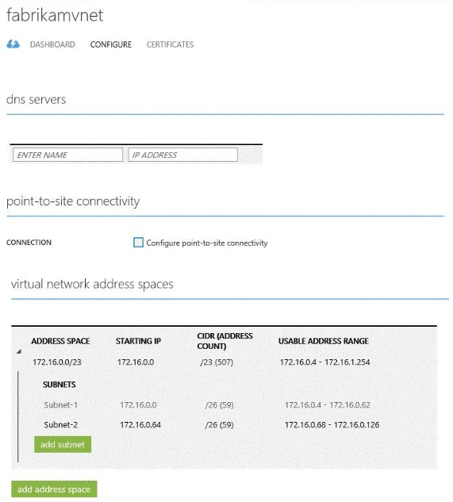

You need to create an internal load balancer named fabLoadBalancer that has a static IP  
address of 172.16.0.100.  
Which value should you use in each parameter of the Power Shell command?  
To answer, drag the appropriate value to the correct location in the Power Shell command.  
Each value may be used once, more than once, or not at all. You may need to drag the  
split bar between panes or scroll to view content.

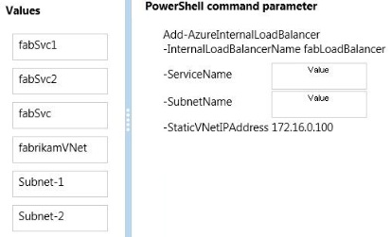

question_answerVIEW ANSWER

SHOW COMMENTS0

Answer :

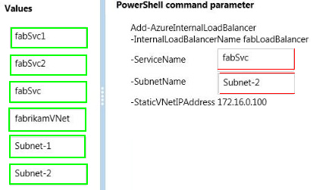

##### Question No : 62 -

You manage an application running on Azure Web Sites Standard tier. The application  
uses a substantial amount of large image files and is used by people around the world.  
Users from Europe report that the load time of the site is slow.  
You need to implement a solution by using Azure services.  
What should you do?

* **A.**Configure Azure blob storage with a custom domain.
* **B.**Configure Azure CDN to cache all responses from the application web endpoint.
* **C.**Configure Azure Web Site auto-scaling to increase instances at high load.
* **D.**Configure Azure CDN to cache site images and content stored in Azure blob storage.

question_answerVIEW ANSWER

SHOW COMMENTS0

Answer : **D**

Explanation: Blobs that benefit the most from Azure CDN caching are those that are accessed frequently during their time-to-live (TTL) period. A blob stays in the cache for the TTL period and then is refreshed by the blob service after that time is elapsed. Then the process repeats. References:

##### Question No : 63 -

A company has an Azure subscription with four virtual machines (VM) that are provisioned  
in an availability set. The VMs support an existing web service. The company expects  
additional demand for the web service. You add 10 new VMs to the environment.  
You need to configure the environment.  
How many Update Domains (UDs) and Fault Domains (FDs) should you create?

* **A.**2 UDs and 5 FDs
* **B.**5 UDs and 2 FDs
* **C.**14 UDs and 2 FDs
* **D.**14 UDs and 14 FDs

question_answerVIEW ANSWER

SHOW COMMENTS7

Answer : **B**

##### Question No : 64 -

You have an Azure subscription.  
You create an Azure Active Directory (Azure AD) tenant named Tenant1 that has a domain  
name of tenant1.onmicrosoft.com. You need to add the contoso.com domain name to  
Tenant1.  
Which DNS record should you add to the contoso.com zone to be able to verify from Azure  
whether you own the contoso.com domain?

* **A.**standard alias (CNAME)
* **B.**mail exchanger (MX)
* **C.**host (AAAA)
* **D.**signature (SIG)

question_answerVIEW ANSWER

SHOW COMMENTS8

Answer : **A**

##### Question No : 65 -

You administer a solution deployed to a virtual machine (VM) in Azure. The VM hosts a  
web service that is used by several applications. You are located in the US West region  
and have a worldwide user base.  
Developers in Asia report that they experience significant delays when they execute the  
services.  
You need to verify application performance from different locations.  
Which type of monitoring should you configure?

* **A.**Disk Read
* **B.**Endpoint
* **C.**Network Out
* **D.**CPU
* **E.**Average Response Time

question_answerVIEW ANSWER

SHOW COMMENTS7

Answer : **A**

##### Question No : 66 -

You administer a DirSync server configured with Azure Active Directory (Azure AD).  
You need to provision a user in Azure AD without waiting for the default DirSync  
synchronization interval.  
What are two possible ways to achieve this goal? Each correct answer presents a  
complete solution.

* **A.**Restart the DirSync server.
* **B.**Run the Start-OnlineCoexistenceSync PowerShell cmdlet.
* **C.**Run the Enable-SyncShare PowerShell cmdlet.
* **D.**Run the Azure AD Sync tool Configuration Wizard.
* **E.**Replicate the Directory in Active Directory Sites and Services.

question_answerVIEW ANSWER

SHOW COMMENTS1

Answer : **B,D**

Explanation: If you dont want to wait for the recurring synchronizations that occur every three hours, you can force directory synchronization at any time. B: Force directory synchronization using Windows PowerShell You can use the directory synchronization Windows PowerShell cmdlet to force synchronization. The cmdlet is installed when you install the Directory Sync tool. On the computer that is running the Directory Sync tool, start PowerShell, type Import- Module DirSync, and then press ENTER. Type Start-OnlineCoexistenceSync, and then press ENTER. D: Azure Active Directory Sync Services (AAD Sync) In September 2014 the Microsoft Azure AD Sync tool was released. This changed how manual sync requests are issued. To perform a manual update we now use the DirectorySyncClientCmd.exe tool. The Delta and Initial parameters are added to the command to specify the relevant task. This tool is located in: C:\Program Files\Microsoft Azure AD Sync\Bin You can use the directory synchronization Windows PowerShell cmdlet to force synchronization. The cmdlet is installed when you install the Directory Sync tool. On the computer that is running the Directory Sync tool, start PowerShell, type Import- Module DirSync, and then press ENTER. Type Start-OnlineCoexistenceSync, and then press ENTER.

##### Question No : 67 -

You manage an Azure Web Site named contosoweb.  
Some users report that they receive the following error when they access contosoweb:  
http Status 500.0 - Internal Server Error.  
You need to view detailed diagnostic information in XML format.  
Which option should you enable? To answer, select the appropriate option in the answer  
area.

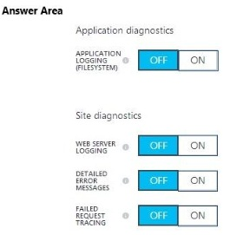

question_answerVIEW ANSWER

SHOW COMMENTS1

Answer :

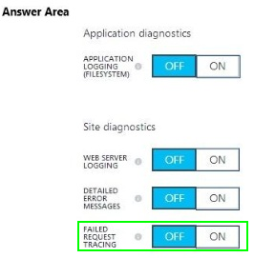

Explanation:

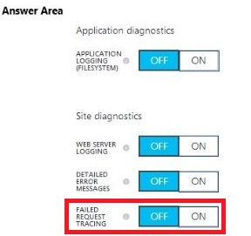

Request-based tracing is available both in stand-alone IIS Servers and on Windows Azure Web Sites (WAWS) and provides a way to determine what exactly is happening with your requests and why, provided that you can reproduce the problem that you are experiencing. Problems like poor performance on some requests, or authentication-related failures on other requests, or the server 500 error from ASP or ASP.NET can often be difficult to troubleshoot--unless you have captured the trace of the problem when it occurs. References:

##### Question No : 68 -

You create a virtual machine (VM) in Azure. The VM runs an important line of business  
application.  
Users report that the application is slow and unstable.  
You need to enable diagnostics for the VM.  
In which order should you perform the actions? To answer, move all actions from the list of  
actions to the answer area and arrange them in the correct order.

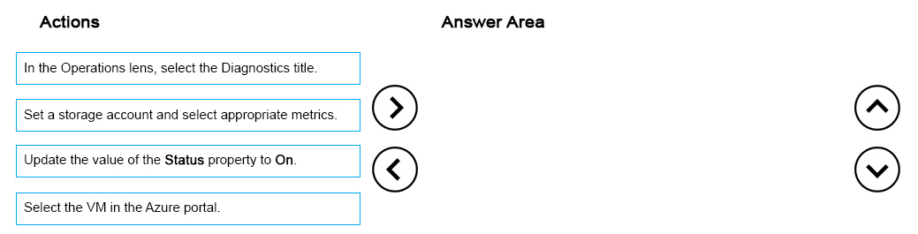

question_answerVIEW ANSWER

SHOW COMMENTS0

Answer :

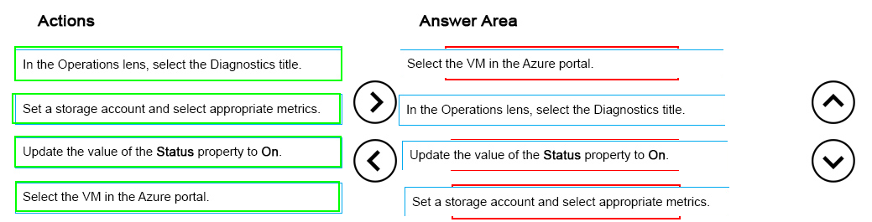

Explanation:

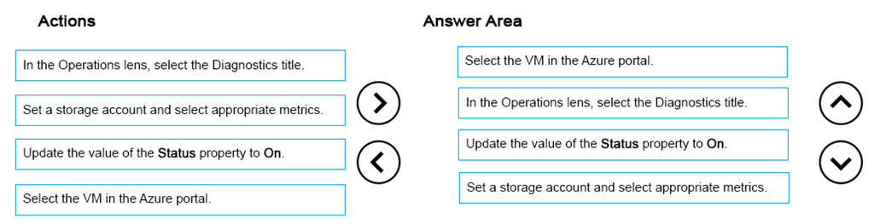

References: https://azure.microsoft.com/en-gb/documentation/articles/insights-how-to-use-diagnostics/

##### Question No : 69 -

You manage an application running on Azure web apps in a Standard tier. The application  
uses a substantial amount of large image files from a storage account and is used by  
people around the world.  
Users from Europe report that the load time of the site is slow.  
You need to implement a solution by using Azure services.  
Which two actions will achieve the goal? Each correct answer presents a complete  
solution.

* **A.**Configure Azure web app auto-scaling to increase instances at high load.
* **B.**Configure Azure CDN to cache all responses from the application web endpoint.. Configure Azure CDN to cache site images and content stored in Azure blob storage.
* **C.**Configure Azure blob storage with a custom domain.

question_answerVIEW ANSWER

SHOW COMMENTS1

Answer : **B,C**

##### Question No : 70 -

You administer a cloud service.  
You plan to host two web applications named contosoweb and contosowebsupport.  
You need to ensure that you can host both applications and qualify for the Azure Service  
Level Agreement. You want to achieve this goal while minimizing costs.  
How should you host both applications?

* **A.**in different web roles with two instances in each web role
* **B.**in the same web role with two instances
* **C.**in different web roles with one instance in each web role
* **D.**in the same web role with one instance

question_answerVIEW ANSWER

SHOW COMMENTS2

Answer : **B**

Explanation: A cloud service must have at least two instances of every role to qualify for the Azure Service Level Agreement, which guarantees external connectivity to your Internet-facing roles at least 99.95 percent of the time. References:

##### Question No : 71 -

A company is developing a new on-premises desktop application.  
The app must be able to access Azure Active Directory (Azure AD) in addition to the on-  
premises Active Directory. You need to configure the application.  
Which two actions should you perform? Each correct answer presents part of the solution.

* **A.**Install and run Azure AD Connect
* **B.**Add an application manifest JSON file to the application and configure the oauth2Permissions section.
* **C.**Update the application to be multi-tenant.
* **D.**Update the application to use OAuth 2.0 authentication.
* **E.**In the Azure Management portal, register the application.

question_answerVIEW ANSWER

SHOW COMMENTS5

Answer : **A,E**

##### Question No : 72 -

You publish a multi-tenant application named MyApp to Azure Active Directory (Azure AD).  
You need to ensure that only directory administrators from the other organizations can  
access MyApp's web API.  
How should you configure MyApp's manifest JSON file? To answer, drag the appropriate  
PowerShell command to the correct location in the application's manifest JSON file. Each  
value may be used once, more than once, or not at all. You may need to drag the split bar  
between panes or scroll to view content.

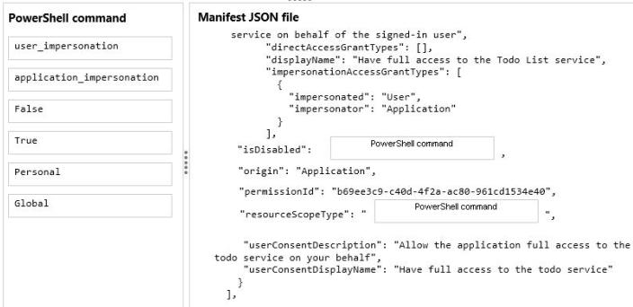

question_answerVIEW ANSWER

SHOW COMMENTS0

Answer :

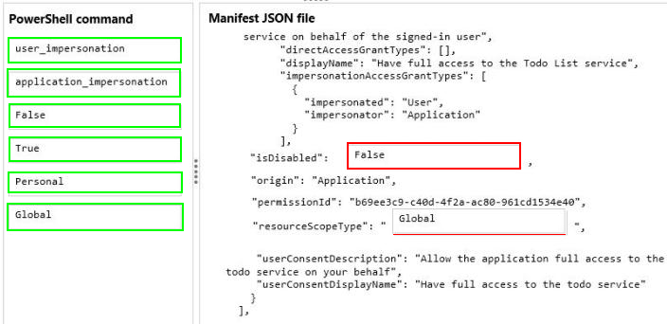

##### Question No : 73 -

You plan to deploy a cloud service named contosoapp. The service includes a web role  
named contosowebrole. The web role has an endpoint named restrictedEndpoint.  
You need to allow access to restricted Endpoint only from your office machine using the IP  
address 145.34.67.82.  
Which values should you use within the service configuration file? To answer, drag the  
appropriate value to the correct location in the service configuration file. Each value may be  
used once, more than once, or not at all. You may need to drag the split bar between  
panes or scroll to view content.

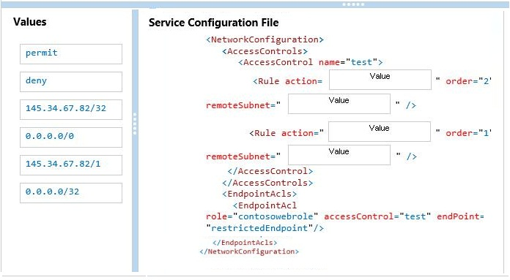

question_answerVIEW ANSWER

SHOW COMMENTS0

Answer :

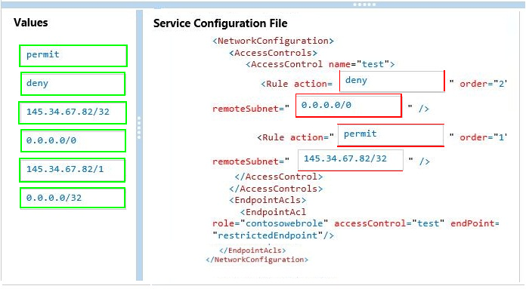

Explanation:

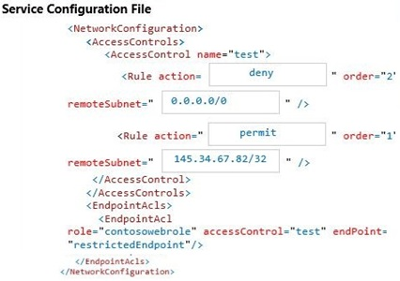

* Rule with lower order are applied first. * We can selectively permit or deny network traffic (in the management portal or from PowerShell) for a virtual machine input endpoint by creating rules that specify permit or deny. By default, when an endpoint is created, all traffic is permitted to the endpoint. So for that reason, its important to understand how to create permit/deny rules and place them in the proper order of precedence to gain granular control over the network traffic that you choose to allow to reach the virtual machine endpoint. Note that at the instant you add one or more permit ranges, you aredenying all other ranges by default. Moving forward from the first permit range, only packets from the permitted IP range will be able to communicate with the virtual machine endpoint.

##### Question No : 74 -

You are migrating a local virtual machine (VM) to an Azure VM. You upload the virtual hard  
disk (VHD) file to Azure Blob storage as a Block Blob.  
You need to change the Block blob to a page blob.  
What should you do?

* **A.**Delete the Block Blob and re-upload the VHD as a page blob.
* **B.**Update the type of the blob programmatically by using the Azure Storage .NET SDK.
* **C.**Update the metadata of the current blob and set the Blob-Type key to Page.
* **D.**Create a new empty page blob and use the Azure Blob Copy Power Shell cmdlet to copy the current data to the new blob.

question_answerVIEW ANSWER

SHOW COMMENTS0

Answer : **A**

Explanation: * To copy the data files to Windows Azure Storage by using one of the following methods: AzCopy Tool, Put Blob (REST API) and Put Page (REST API), or Windows Azure Storage Client Library for .NET or a third-party storage explorer tool. Important: When using this new enhancement, always make sure that you create a page blob not a block blob. * Azure has two main files storage format: Page blob : mainly used for vhds (CloudPageBlob) Block Blob : for other files (CloudBlockBlob) References:

##### Question No : 75 -

You manage a cloud service that utilizes data encryption.  
You need to ensure that the certificate used to encrypt data can be accessed by the cloud  
service application.  
What should you do?

* **A.**Upload the certificate referenced in the application package.
* **B.**Deploy the certificate as part of the application package.
* **C.**Upload the certificate’s public key referenced in the application package.
* **D.**Use RDP to install the certificate.

question_answerVIEW ANSWER

SHOW COMMENTS5

Answer : **A**

##### Question No : 76 -

Your company has a subscription to Azure.  
You configure your contoso.com domain to use a private Certificate Authority. You deploy a  
web site named MyApp by using the Shared (Preview) web hosting plan.  
You need to ensure that clients are able to access the MyApp website by using https.  
What should you do?

* **A.**Back up the Site and import into a new website.
* **B.**Use the internal Certificate Authority and ensure that clients download the certificate chain.
* **C.**Add custom domain SSL support to your current web hosting plan.
* **D.**Change the web hosting plan to Standard.

question_answerVIEW ANSWER

SHOW COMMENTS2

Answer : **D**

Explanation: Enabling HTTPS for a custom domain is only available for the Standard web hosting plan mode of Azure websites. References:

##### Question No : 77 -

You administer an Azure Active Directory (Azure AD) tenant that has a SharePoint web  
application named TeamSite1. TeamSite1 accesses your Azure AD tenant for user  
information.  
The application access key for TeamSite1 has been compromised.  
You need to ensure that users can continue to use TeamSite1 and that the compromised  
key does not allow access to the data in your Azure AD tenant.  
Which two actions should you perform? Each correct answer presents part of the solution.

* **A.**Remove the compromised key from the application definition for TeamSite1.
* **B.**Delete the application definition for TeamSite1.
* **C.**Generate a new application key for TeamSite1.
* **D.**Generate a new application definition for TeamSite1.
* **E.**Update the existing application key.

question_answerVIEW ANSWER

SHOW COMMENTS2

Answer : **A,C**

Explanation: One of the security aspects of Windows Azure storage is that all access is protected by access keys. It is possible to change the access keys (e.g. if the keys become compromised), and if changed, wed need to update the application to have the new key.

##### Question No : 78 -

Fourth Coffee has an on-premises, multiple-forest Activity Directory (AD) domain. The  
company hosts web applications and mobile application services. Fourth Coffee uses  
Microsoft Office 365 and uses Azure Active Directory (Azure AD).  
You have the following requirements:  
Which three actions should you perform in sequence? To answer, move the appropriate  
actions from the list of actions to the answer area and arrange them in the correct order.

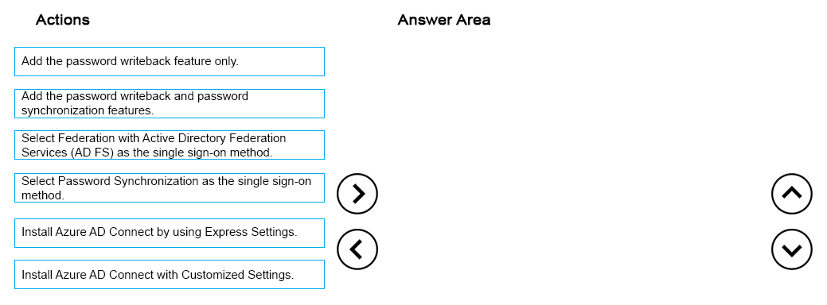

question_answerVIEW ANSWER

SHOW COMMENTS3

Answer :

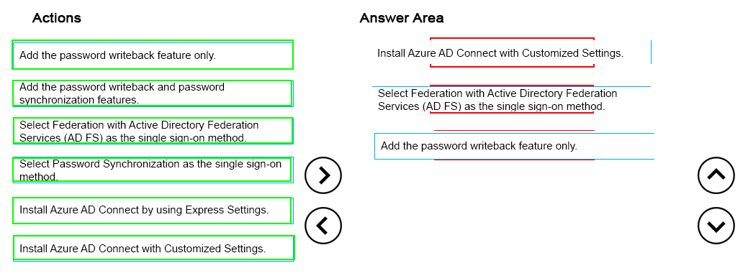

Explanation:

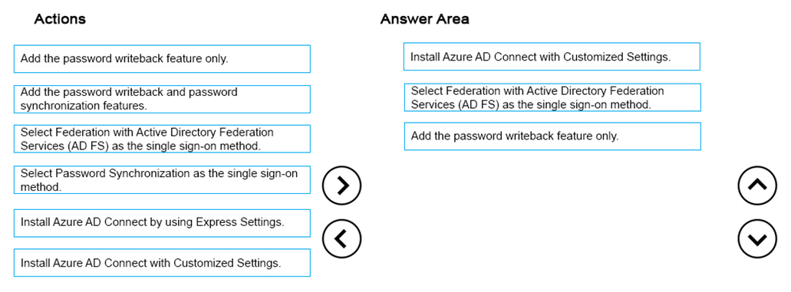

References: https://azure.microsoft.com/en-gb/documentation/articles/active-directory-passwords- getting-started/#writeback-prerequisites https://azure.microsoft.com/en-gb/documentation/articles/active-directory-aadconnect-get- started-custom/

##### Question No : 79 -

You manage a web application named Contoso that is accessible from the URL  
http://www.contoso.com.  
You need to view a live stream of log events for the web application.  
How should you configure the Azure PowerShell command? T answer, select the  
appropriate Azure PowerShell segment from each list in the answer area.

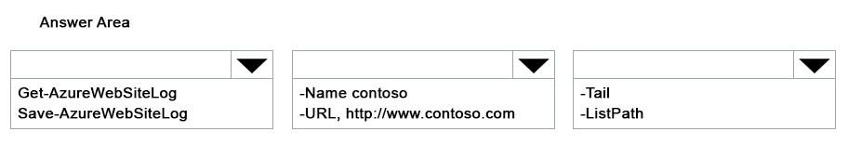

question_answerVIEW ANSWER

SHOW COMMENTS0

Answer :

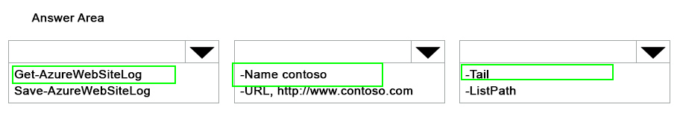

Explanation:

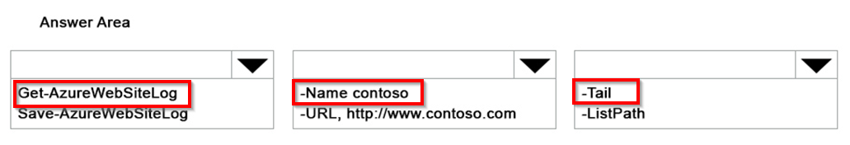

References: https://msdn.microsoft.com/en-us/library/azure/dn495187.aspx

##### Question No : 80 -

Your company has a subscription to Azure. You plan to deploy 10 websites.  
You have the following requirements:  
You need to deploy the 10 websites while minimizing costs.  
Which web tier plan should you recommend?

* **A.**Free
* **B.**Small Business
* **C.**Standard
* **D.**Basic

question_answerVIEW ANSWER

SHOW COMMENTS3

Answer : **C**

Explanation: Standard offers 50 GB of storage space, while Basic only gives 10 GB: References:

##### Question No : 81 -

You manage a collection of large video files that is stored in an Azure Storage account.  
A user wants access to one of your video files within the next seven days.  
You need to allow the user access only to the video file, and then revoke access once the  
user no longer needs it.  
What should you do?

* **A.**Give the user the secondary key for the storage account.Once the user is done with the file, regenerate the secondary key.
* **B.**Create an Ad-Hoc Shared Access Signature for the Blob resource.Set the Shared Access Signature to expire in seven days.
* **C.**Create an access policy on the container.Give the external user a Shared Access Signature for the blob by using the policy.Once the user is done with the file, delete the policy.
* **D.**Create an access policy on the blob.Give the external user access by using the policy.Once the user is done with the file, delete the policy.

question_answerVIEW ANSWER

SHOW COMMENTS5

Answer : **C**

Explanation: See 3) below. By default, only the owner of the storage account may access blobs, tables, and queues within that account. If your service or application needs to make these resources available to other clients without sharing your access key, you have the following options for permitting access: 1.You can set a container's permissions to permit anonymous read access to the container and its blobs. This is not allowed for tables or queues. 2. You can expose a resource via a shared access signature, which enables you to delegate restricted access to a container, blob, table or queue resource by specifying the interval for which the resources are available and the permissions that a client will have to it. 3. You can use a stored access policy to manage shared access signatures for a container or its blobs, for a queue, or for a table. The stored access policy gives you an additional measure of control over your shared access signatures and also provides a straightforward means to revoke them. References:

##### Question No : 82 -

You administer an Access Control Service namespace named contosoACS that is used by  
a web application. ContosoACS currently utilizes Microsoft and Yahoo accounts.  
Several users in your organization have Google accounts and would like to access the web  
application through ContosoACS.  
You need to allow users to access the application by using their Google accounts.  
What should you do?

* **A.**Register the application directly with Google.
* **B.**Edit the existing Microsoft Account identity provider and update the realm to include Google.
* **C.**Add a new Google identity provider.
* **D.**Add a new WS-Federation identity provider and configure the WS-Federation metadata to point to the Google sign-in URL.

question_answerVIEW ANSWER

SHOW COMMENTS0

Answer : **C**

Explanation: Configuring Google as an identity provider eliminates the need to create and manage authentication and identity management mechanism. It helps the end user experience if there are familiar authentication procedures. References:

##### Question No : 83 -

You administer an Azure virtual network named fabrikamVNet.  
You need to deploy a virtual machine (VM) and ensure that it is a member of the  
fabrikamVNet virtual network. Which two actions will achieve the goal? Each correct  
answer presents a complete solution.

* **A.**Run the following Windows PowerShell cmdlet:New-AzureVM
* **B.**Run the following Windows PowerShell cmdlet:New-AzureAffinityGroup
* **C.**Update fabrikamVNet’s existing Availability Set.
* **D.**Run the following Windows PowerShell cmdlet:New-AzureQuickVM

question_answerVIEW ANSWER

SHOW COMMENTS0

Answer : **A,D**

##### Question No : 84 -

You manage a cloud service that utilizes an Azure Service Bus queue.  
You need to ensure that messages that are never consumed are retained.  
What should you do?

* **A.**Run the following Azure PowerShell cmdlet:New-AzureSchedulerStorageQueueJob
* **B.**From the Azure portal, create a new queue named Dead-Letter.
* **C.**In the Azure portal, select the MOVE TO THE DEAD-LETTER SUBQUEUE option for expired messages.
* **D.**Run the following Azure PowerShell cmdlet:Set-AzureServiceBus

question_answerVIEW ANSWER

SHOW COMMENTS0

Answer : **C**

##### Question No : 85 -

You administer an Azure solution that uses a virtual network named FabVNet. FabVNet  
has a single subnet named Subnet-1.  
You discover a high volume of network traffic among four virtual machines (VMs) that are  
part of Subnet-1.  
You need to isolate the network traffic among the four VMs. You want to achieve this goal  
with the least amount of downtime and impact on users.  
What should you do?

* **A.**Create a new subnet in the existing virtual network and move the four VMs to the new subnet.
* **B.**Create a site-to-site virtual network and move the four VMs to your datacenter.
* **C.**Create a new virtual network and move the VMs to the new network.
* **D.**Create an availability set and associate the four VMs with that availability set.

question_answerVIEW ANSWER

SHOW COMMENTS5

Answer : **C**

##### Question No : 86 -

Your company network has two physical locations configured in a geo-clustered  
environment. You create a Blob storage account in Azure that contains all the data  
associated with your company.  
You need to ensure that the data remains available in the event of a site outage.  
Which storage option should you enable?

* **A.**Locally redundant storage
* **B.**Geo-redundant storage
* **C.**Zone-redundant storage
* **D.**Read-only geo-redundant storage

question_answerVIEW ANSWER

SHOW COMMENTS0

Answer : **D**

Explanation: Introducing Read-only Access to Geo Redundant Storage (RA-GRS): RA-GRS allows you to have higher read availability for your storage account by providing read only access to the data replicated to the secondary location. Once you enable this feature, the secondary location may be used to achieve higher availability in the event the data is not available in the primary region. This is an opt-in feature which requires the storage account be geo-replicated. References:

##### Question No : 87 -

Your company has recently signed up for Azure.  
You plan to register a Data Protection Manager (DPM) server with the Azure Backup  
service.  
You need to recommend a method for registering the DPM server with the Azure Backup  
vault.  
What are two possible ways to achieve this goal? Each correct answer presents a  
complete solution.

* **A.**Import a self-signed certificate created using the makecert tool.
* **B.**Import a self-signed certificate created using the createcert tool.
* **C.**Import an X.509 v3 certificate with valid clientauthentication EKU.
* **D.**Import an X.509 v3 certificate with valid serverauthentication EKU.

question_answerVIEW ANSWER

SHOW COMMENTS0

Answer : **A,C**

Explanation: A: You can create a self-signed certificate using the makecert tool, or use any valid SSL certificate issued by a Certification Authority (CA) trusted by Microsoft, whose root certificates are distributed via the Microsoft Root Certificate Program. C: The certificate must have a valid ClientAuthentication EKU. References:

##### Question No : 88 -

You manage two datacenters in different geographic regions and one branch office.  
You plan to implement a geo-redundant backup solution.  
You need to ensure that each datacenter is a cold site for the other.  
You create a recovery vault. What should you do next?

* **A.**Install the provider.
* **B.**Upload a certificate to the vault.
* **C.**Generate a vault key.
* **D.**Set all virtual machines to DHCP.
* **E.**Prepare System Center Virtual Machine Manager (SCVMM) servers.
* **F.**Create mappings between the virtual machine (VM) networks.

question_answerVIEW ANSWER

SHOW COMMENTS1

Answer : **C**

Explanation: References:

##### Question No : 89 -

You migrate a Windows Server .NET web application to Azure Cloud Services.  
You need enable trace logging for the application.  
Which two actions should you perform? Each correct answer presents part of the solution.

* **A.**Update the service definition file.
* **B.**Update the Azure diagnostics configuration.
* **C.**Update the service configuration file.
* **D.**Enable verbose monitoring.
* **E.**Update the application web.config file.

question_answerVIEW ANSWER

SHOW COMMENTS4

Answer : **A,E**

Explanation: References:

##### Question No : 90 -

You publish an application named MyApp to Azure Active Directory (Azure AD). You grant  
access to the web APIs through OAuth 2.0.  
MyApp is generating numerous user consent prompts.  
You need to reduce the amount of user consent prompts.  
What should you do?

* **A.**Enable Multi-resource refresh tokens.
* **B.**Enable WS-federation access tokens.
* **C.**Configure the Open Web Interface for .NET.
* **D.**Configure SAML 2.0.

question_answerVIEW ANSWER

SHOW COMMENTS0

Answer : **A**

Explanation: When using the Authorization Code Grant Flow, you can configure the client to call multiple resources. Typically, this would require a call to the authorization endpoint for each target service. To avoid multiple calls and multiple user consent prompts, and reduce the number of refresh tokens the client needs to cache, Azure Active Directory (Azure AD) has implemented multi-resource refresh tokens. This feature allows you to use a single refresh token to request access tokens for multiple resources. References:

##### Question No : 91 -

Your company has two cloud services named CS01 and CS02. You create a virtual  
machine (VM) in CS02 named Accounts.  
You need to ensure that users in CS01 can access the Accounts VM by using port 8080.  
What should you do?

* **A.**Create a firewall rule.
* **B.**Configure load balancing.
* **C.**Configure port redirection.
* **D.**Configure port forwarding.
* **E.**Create an end point.

question_answerVIEW ANSWER

SHOW COMMENTS0

Answer : **E**

Explanation: All virtual machines that you create in Azure can automatically communicate using a private network channel with other virtual machines in the same cloud service or virtual network. However, other resources on the Internet or other virtual networks require endpoints to handle the inbound network traffic to the virtual machine. References:

##### Question No : 92 -

You manage an Azure Web Site named salessite1. You notice some performance issues  
with salessite1. You create a new database for salessite1.  
You need to update salessite1 with the following changes, in the order shown:  
1. Display the list of current connection strings.  
2. Create a new connection string named conn1 with a value of:  
Server=tcp:samplel.database.windows.net,1433;Database=NewDB;User  
ID=User@samplel;Password=Passwordl;Trusted_Connection=False;Encrypt=True;Connec  
tion Timeout=30;.  
3. Download the application logs for analysis.  
Which three xplat-cli commands should you perform in sequence? To answer, move the  
appropriate commands from the list of commands to the answer area and arrange them in  
the correct order.

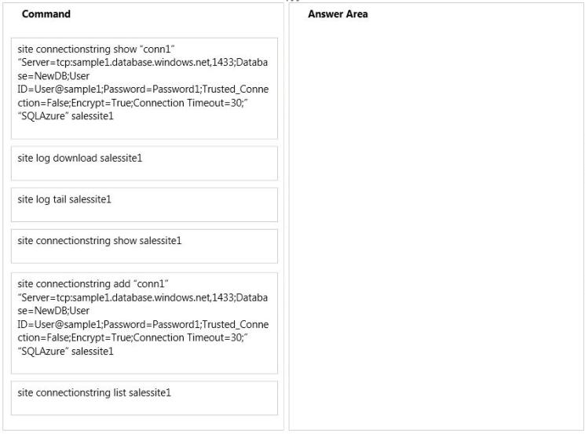

question_answerVIEW ANSWER

SHOW COMMENTS0

Answer :

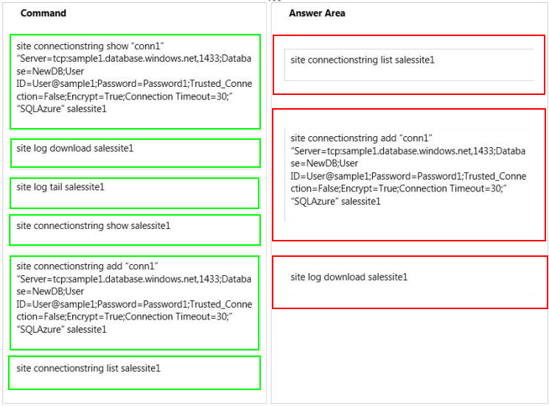

Explanation: Box 1:

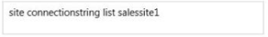

Box 2:

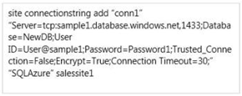

Box 3:

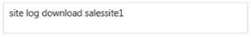

* site connectionstring list * site connectionstring add * site log download azure site log download websitename This will download the log files for the website specified by websitename and save them to a log.zip file in the current directory. Note: Commands to manage your Website connection strings site connectionstring list [options] [name] site connectionstring add [options] <connectionname> <value> <type> [name] site connectionstring delete [options] <connectionname> [name] site connectionstring show [options] <connectionname> [name]

##### Question No : 93 -

You manage a public-facing web application which allows authenticated users to upload  
and download large files. On the initial public page there is a promotional video.  
You plan to give users access to the site content and promotional video.  
In the table below, identify the access method that should be used for the anonymous and  
authenticated parts of the application. Make only one selection in each column.

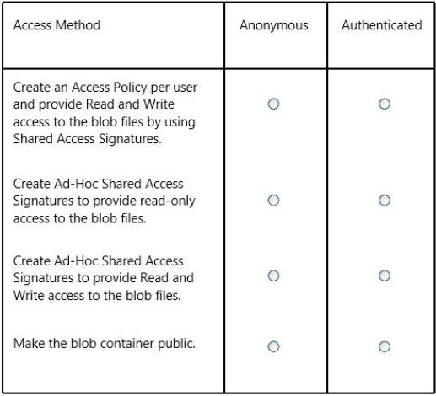

question_answerVIEW ANSWER

SHOW COMMENTS0

Answer :

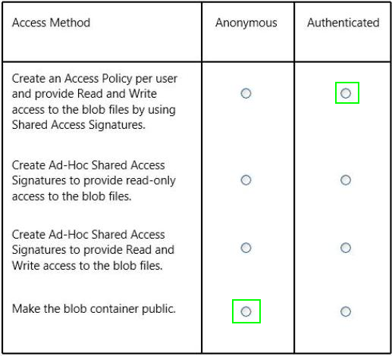

##### Question No : 94 -

You manage a web application that currently uses a small instance size.  
You need to scale the instance size to medium.  
How should you complete the Azure PowerShell script? To answer, drag the appropriate  
Azure PowerShell segments to the correct locations. Each Azure PowerShell segment may  
be used once, more than once, or not at all. You may need to drag the split bar between  
panes or scroll to view content.

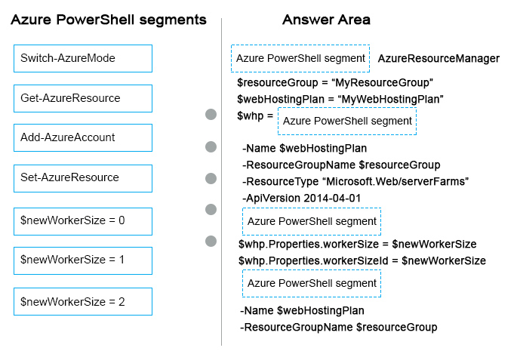

question_answerVIEW ANSWER

SHOW COMMENTS1

Answer :

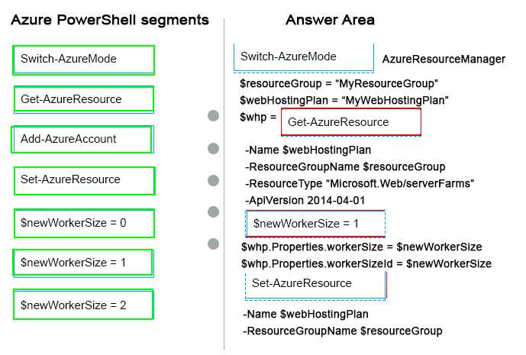

##### Question No : 95 -

You manage an Azure Service Bus for your company. You plan to enable access to the  
Azure Service Bus for an application named ContosoLOB.  
You need to create a new shared access policy for subscriptions and queues that has the  
following requirements:  
In the table below, identify the permission you need to assign to ensure that ContosoLOB is  
able to accomplish the above requirements. Make only one selection in each column.

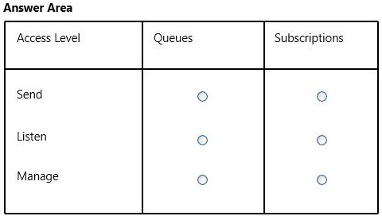

question_answerVIEW ANSWER

SHOW COMMENTS1

Answer :

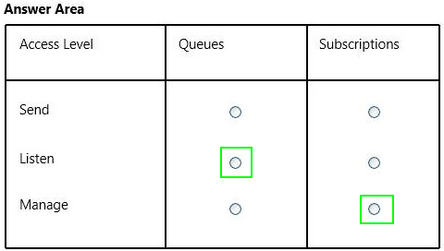

Explanation:

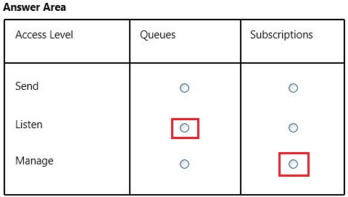

For Service Bus, the three permission claims are Send for all send operations, Listen to open up listeners or receive messages, and Manage to observe or manage the state of the Service Bus tenant. References:

##### Question No : 96 -

You manage two solutions in separate Azure subscriptions.  
You need to ensure that the two solutions can communicate on a private network.  
Which three actions should you perform in sequence? To answer, move the appropriate  
actions from the list of actions to the answer area and arrange them in the correct order.

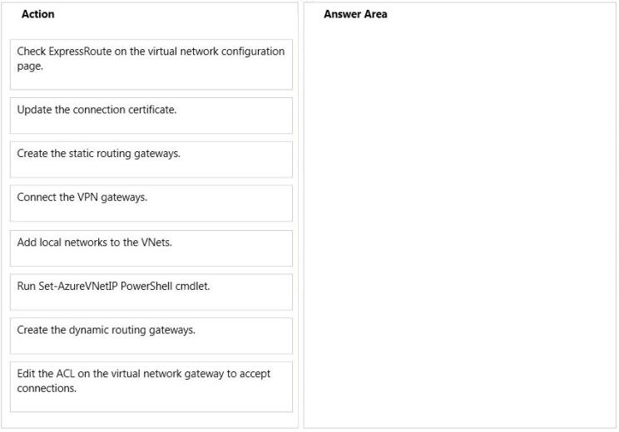

question_answerVIEW ANSWER

SHOW COMMENTS0

Answer :

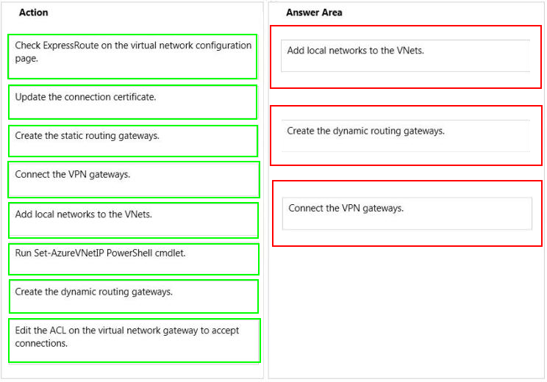

Explanation: Box 1:

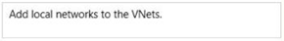

Box 2:

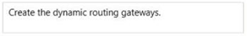

Box 3:

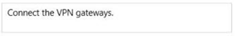

Configure a VNet to VNet connection There are 5 sections to plan and configure. Configure each section in the order listed below: 1. Plan your IP address ranges 2. Create your virtual networks 3. Add local networks 4. Create the dynamic routing gateways for each VNet. 5. Connect the VPN gateways Note: In this procedure, well walk you through connecting two virtual networks, VNet1 and VNet2. Youll need to be comfortable with networking in order to substitute the IP address ranges that are compatible with your network design requirements. From an Azure virtual network, connecting to another Azure virtual network is the same as connecting to an on premises network via Site-to-site (S2S) VPN. This procedure primarily uses the Management Portal, however, you must use Microsoft Azure PowerShell cmdlets to connect the VPN gateways. References:

##### Question No : 97 -

You manage an application deployed to a cloud service that utilizes an Azure Storage  
account.  
The cloud service currently uses the primary access key.  
Security policy requires that all shared access keys are changed without causing  
application downtime.  
Which three steps should you perform in sequence? To answer, move the appropriate  
actions from the list of actions to the answer area and arrange them in the correct order.

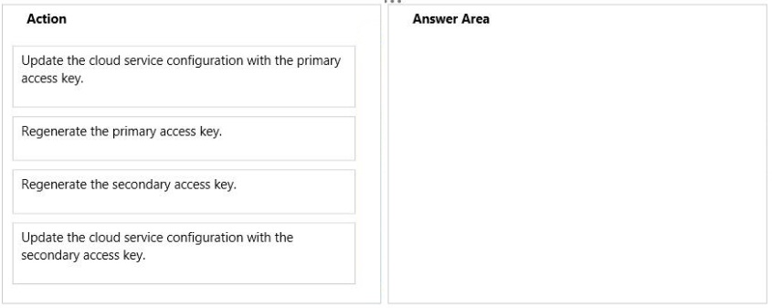

question_answerVIEW ANSWER

SHOW COMMENTS2

Answer :

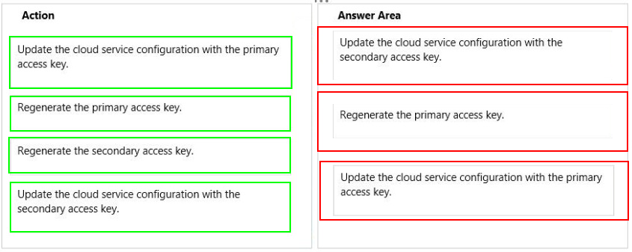

##### Question No : 98 -

You manage an Internet Information Services (IIS) 6 website named contososite1.  
Contososite1 runs a legacy ASP.NET 1.1 application named LegacyApp1. LegacyApp1  
does not contain any integration with any other systems or programming languages.  
You deploy contososite1 to Azure Web Sites.  
You need to configure Azure Web Sites. You have the following requirements:  
Which settings should you configure to meet the requirements? To answer, select the  
appropriate settings in the answer area.

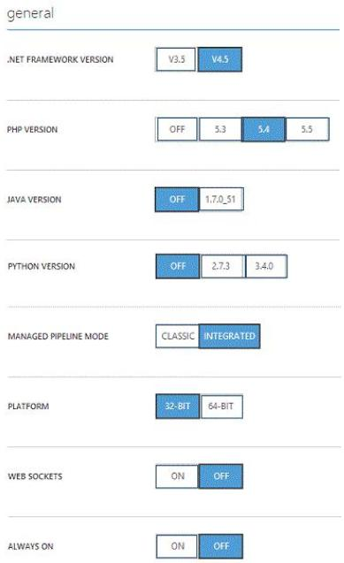

question_answerVIEW ANSWER

SHOW COMMENTS2

Answer :

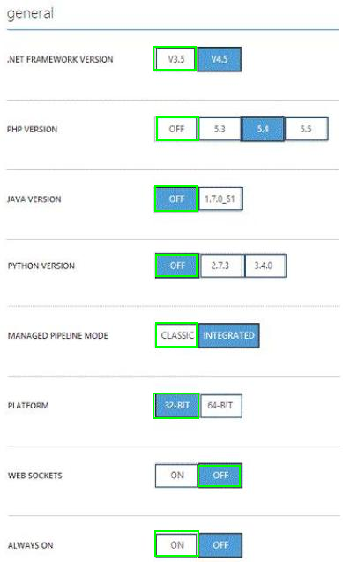

Explanation:

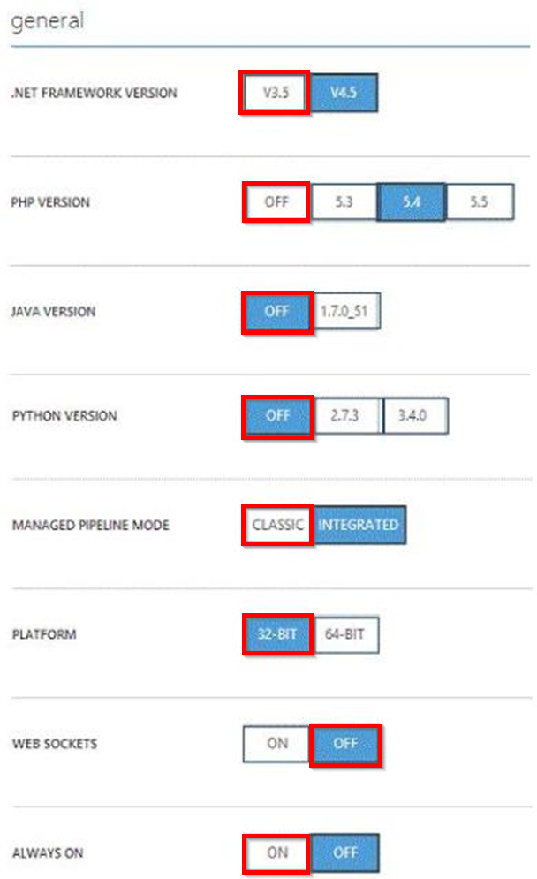

* Managed Pipeline Mode. Sets the IIS pipeline mode. Leave this set to Integrated (the default) unless you have a legacy website that requires an older version of IIS * Always on: ON Always On. By default, websites are unloaded if they are idle for some period of time. This lets the system conserve resources. In Basic or Standard mode, you can enable Always On to keep the site loaded all the time. If your site runs continuous web jobs, you should enable Always On, or the web jobs may not run reliably References:

##### Question No : 99 -

You administer an Azure Virtual Machine (VM) named CON-CL1. CON-CL1 is in a cloud  
service named ContosoService1.  
You discover unauthorized traffic to CON-CL1. You need to:  
Which Azure Power Shell cmdlets and values should you use? To answer, drag the  
appropriate cmdlet or value to the correct location in the Power Shell command. Each  
cmdlet or value may be used once, more than once, or not at all. You may need to drag the  
split bat between panes or scroll to view content.

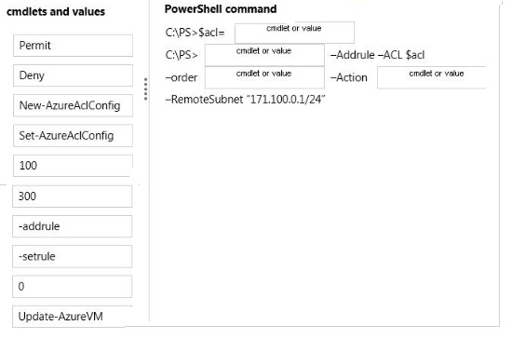

question_answerVIEW ANSWER

SHOW COMMENTS4

Answer :

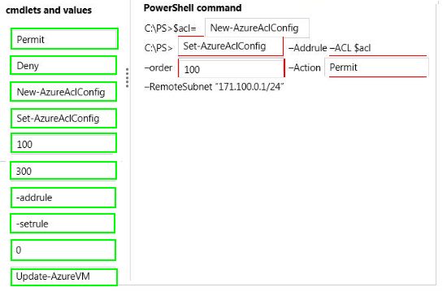

Explanation:

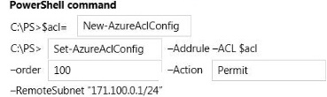

* Example 1 This example uses two commands: The first command creates a new ACL object and stores it in a variable named $acl1. The second command updates the ACL object with a rule that permits incoming network traffic only from remote subnet 10.0.0.0/8. Windows PowerShell PS C:\> $acl1 = New-AzureAclConfigC:\PS> Set-AzureAclConfig AddRule ACL $acl1 Order 100 Action permit RemoteSubnet 10.0.0.0/8 *Parameter: -Order<Int32> Specifies the relative order in which this rule should be processed compared to the other rules applied to the ACL object. The lowest order takes precedence. References:

##### Question No : 100 -

You administer an Azure Web Site named contoso. You create a job named  
Cleanlogs.cmd that will be executed manually, twice a week.  
You need to deploy the job.  
To which folder location should you deploy CleanLogs.cmd?

* **A.**./App_Code/jobs/triggered/cleanLogs/CleanLogs.cmd
* **B.**./App_Data/jobs/triggered/clean Logs/CleanLogs.cmd
* **C.**./App_Code/jobs/continuous/cleanLogs/CleanLogs.cmd
* **D.**./App_Data/jobs/continuous/cleanLogs/CleanLogs.cmd

question_answerVIEW ANSWER

SHOW COMMENTS0

Answer : **B**

Explanation: A WebJob is stored under the following directory in your site: site\wwwroot\App_Data\jobs\{job type}\{job name} Where {job type} can be either continuous for a job that is always running or triggered for a job that starts from an external trigger (on demand / scheduler). References:

##### Question No : 101 -

You administer a cloud service named contosoapp that has a web role and worker role.  
Contosoapp requires you to perform an in-place upgrade to the service.  
You need to ensure that at least six worker role instances and eight web role instances are  
available when you apply upgrades to the service. You also need to ensure that updates  
are completed for all instances by using the least amount of time.  
Which value should you use with each configuration? To answer, drag the appropriate  
value to the correct configuration. Each value may be used once, more than once, or not at  
all. You may need to drag the split bar between panes or scroll to view content.

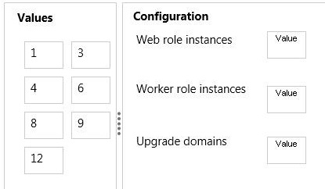

question_answerVIEW ANSWER

SHOW COMMENTS0

Answer :

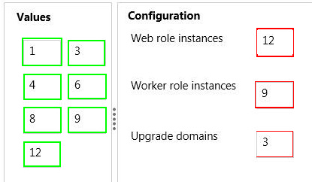

Explanation:

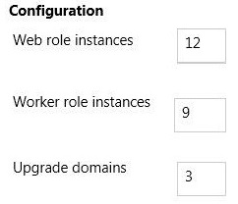

* Scenario: You need to ensure that at least six worker role instances and eight web role instances are available when you apply upgrades to the service. * You can decide whether you want to update all of the roles in your service or a single role in the service. In either case, all instances of each role that is being upgraded and belong to the first upgrade domain are stopped, upgraded, and brought back online. Once they are back online, the instances in the second upgrade domain are stopped, upgraded, and brought back online. References:

##### Question No : 102 -

You manage two websites for your company. The sites are hosted on an internal server  
that is beginning to experience performances issues due to high traffic.  
You plan to migrate the sites to Azure Web Sites.  
The sites have the following configurations:

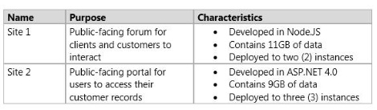

In the table below, identity the web hosting plan with the lowest cost for each site. Make  
only one selection in each column.

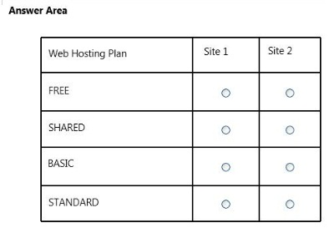

question_answerVIEW ANSWER

SHOW COMMENTS0

Answer :

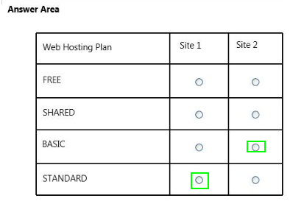

Explanation:

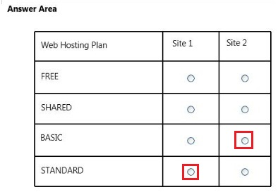

Site 2 contains 9 GB of data so Basic mode is enough as it provided 10 GB of data (FREE and Shared only provide 1 GB of data). Site 1 contains 11 GB of data so Standard mode is adequate as it provided 50 GB of data. References:

##### Question No : 103 -

You develop a Windows Store application that has a web service backend.  
You plan to use the Azure Active Directory Authentication Library to authenticate users to  
Azure Active Directory (Azure AD) and access directory data on behalf of the user.  
You need to ensure that users can log in to the application by using their Azure AD  
credentials.  
Which two actions should you perform? Each correct answer presents part of the solution.

* **A.**Create a native client application in Azure AD.
* **B.**Configure directory integration.
* **C.**Create a web application in Azure AD.
* **D.**Enable workspace join.
* **E.**Configure an Access Control namespace.

question_answerVIEW ANSWER

SHOW COMMENTS4

Answer : **B,C**

Explanation: B: An application that wants to outsource authentication to Azure AD must be registered in Azure AD, which registers and uniquely identifies the app in the directory. C (not A): NativeClient-WindowsStore A Windows Store application that calls a web API that is secured with Azure AD.

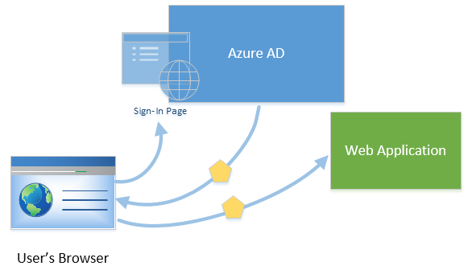

References:

##### Question No : 104 -

You administer an Azure SQL database named contosodb that is running in Standard/S1  
tier. The database is in a server named server1 that is a production environment. You also  
administer a database server named server2 that is a test environment. Both database  
servers are in the same subscription and the same region but are on different physical  
clusters.  
You need to copy contosodb to the test environment.  
Which three steps should you perform in sequence? To answer, move the appropriate  
actions from the list of actions to the answer area and arrange them in the correct order.

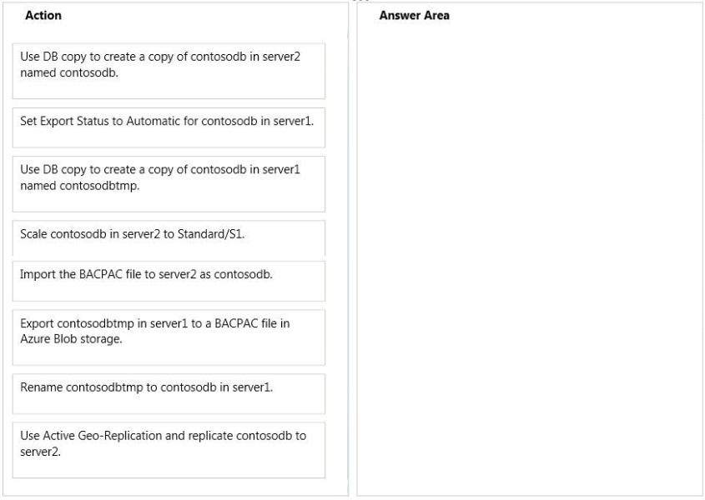

question_answerVIEW ANSWER

SHOW COMMENTS4

Answer :

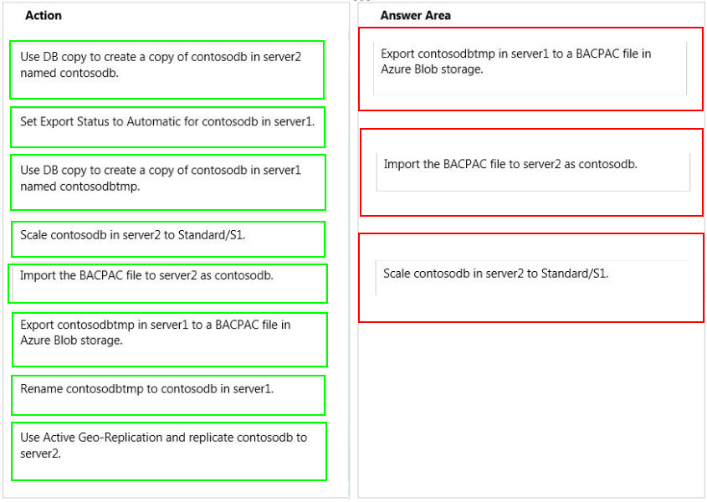

Explanation: Box 1:

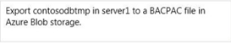

Box 2:

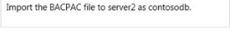

Box 3:

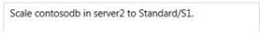

* (Step 1, Step 2): Export a Database from Azure SQL Databas After the export operation is complete, you can then import your BACPAC file to create a new Azure SQL Database or SQL Server database. Incorrect: Active Geo-Replication is available for databases in the Premium service tier only. References:

##### Question No : 105 -

You administer an Azure Web Site named contosoweb that uses a production database.  
You deploy changes to contosoweb from a deployment slot named contosoweb-staging.  
You discover issues in contosoweb that are affecting customer data.  
You need to resolve the issues in contosoweb while ensuring minimum downtime for users.  
You swap contosoweb to contosoweb-staging.  
Which four steps should you perform next in sequence? To answer, move the appropriate  
actions from the list of actions to the answer area and arrange them in the correct order.

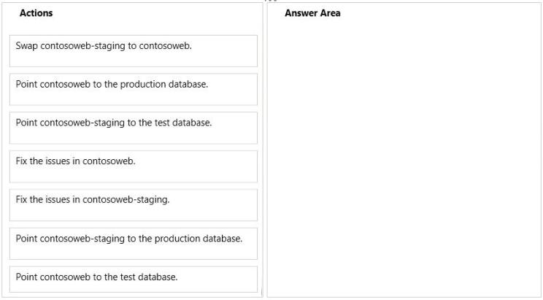

question_answerVIEW ANSWER

SHOW COMMENTS3

Answer :

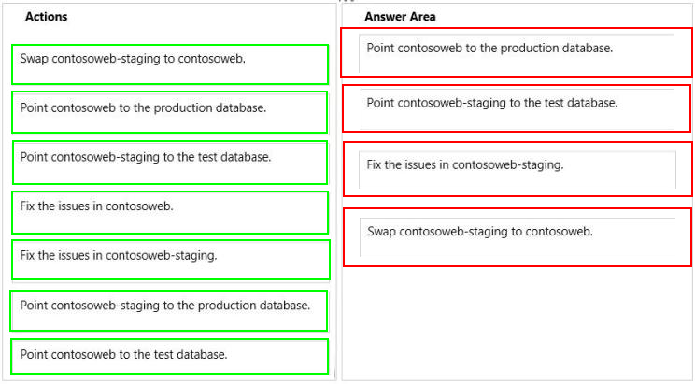

Explanation: Box 1:

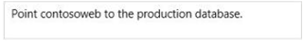

Box 2:

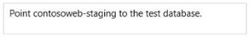

Box 3:

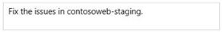

Box 4:

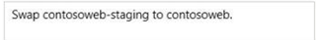

Note: Step 1: Make sure old production database is online. Step 2: Set up staging database with the test database. Step 3: Fix issues with test database. Step 4: Once you have deployed and tested your new version on the staging environment, simply click the SWAP button and Azure immediately makes your staging environment the live onen References:

##### Question No : 106 -

You manage a cloud service that utilizes an Azure Service Bus queue.  
You need to ensure that messages that are never consumed are retained.  
What should you do?

* **A.**Check the MOVE TO THE DEAD-LETTER SUBQUEUE option for Expired Messages in the Azure Portal.
* **B.**From the Azure Management Portal, create a new queue and name it Dead-Letter.
* **C.**Execute the Set-AzureServiceBus PowerShell cmdlet.
* **D.**Execute the New-AzureSchedulerStorageQueueJob PowerShell cmdlet.

question_answerVIEW ANSWER

SHOW COMMENTS0

Answer : **A**

Explanation: The EnableDeadLetteringOnMessageExpiration property allows to enable\disable the dead-lettering on message expiration. References:

##### Question No : 107 -

Your network environment includes remote employees.  
You need to create a secure connection for the remote employees who require access to  
your Azure virtual network.  
What should you do?

* **A.**Deploy Windows Server 2012 RRAS.
* **B.**Configure a point-to-site VPN.
* **C.**Configure an ExpressRoute.
* **D.**Configure a site-to-site VPN.

question_answerVIEW ANSWER

SHOW COMMENTS0

Answer : **B**

Explanation: New Point-To-Site Connectivity With todays release weve added an awesome new feature that allows you to setup VPN connections between individual computers and a Windows Azure virtual network without the need for a VPN device. We call this feature Point-to-Site Virtual Private Networking. This feature greatly simplifies setting up secure connections between Windows Azure and client machines, whether from your office environment or from remote locations. It is especially useful for developers who want to connect to a Windows Azure Virtual Network (and to the individual virtual machines within it) from either behind their corporate firewall or a remote location. Because it is point-to-site they do not need their IT staff to perform any activities to enable it, and no VPN hardware needs to be installed or configured. Instead you can just use the built-in Windows VPN client to tunnel to your Virtual Network in Windows Azure. References:

##### Question No : 108 -

You purchase an Azure subscription. You plan to deploy an application that requires four  
Azure virtual machines (VMs). All VMs use Azure Resource Management (ARM) mode.  
You need to minimize the time that it takes for VMs to communicate with each other.  
What should you do?

* **A.**Create a multi-site virtual network.
* **B.**Create a regional virtual network.
* **C.**Create a site-to-site virtual network.
* **D.**Add the VMs to the same affinity group.

question_answerVIEW ANSWER

SHOW COMMENTS6

Answer : **D**

##### Question No : 109 -

Your network includes a legacy application named LegacyApp1. The application only runs  
in the Microsoft .NET 3.5 Framework on Windows Server 2008.  
You plan to deploy to Azure Cloud Services.  
You need to ensure that LegacyApp1 will run correctly in the new environment.  
What are two possible ways to achieve this goal? Each correct answer presents a  
complete solution.

* **A.**Upload a VHD with Windows Server 2008 installed.
* **B.**Deploy LegacyApp1 to a cloud service instance configured with Guest OS Family 2.
* **C.**Deploy LegacyApp1 to a cloud service instance configured with Guest OS Family 1.
* **D.**Deploy LegacyApp1 to a cloud service instance configured with Guest OS Family 3.

question_answerVIEW ANSWER

SHOW COMMENTS3

Answer : **B,C**

Explanation: Guest OS Family 1 and Guest OS Family 2 supports .NET 3.5 and .Net 4.0. Guest OS Family 3 and Guest OS Family 4 supports .NET 4.0 and .Net 4.5. References:

##### Question No : 110 -

You plan to use Password Sync on your DirSync Server with Azure Active Directory {Azure  
AD) on your company network. You configure the DirSync server and complete an initial  
synchronization of the users.  
Several remote users are unable to log in to Office 365. You discover multiple event log  
entries for "Event ID 611 Password synchronization failed for domain."  
You need to resolve the password synchronization issue.  
Which two actions should you perform? Each correct answer presents part of the solution.

* **A.**Restart Azure AD Sync Service.
* **B.**Run the Set-FullPasswordSync Power Shell cmdlet.
* **C.**Force a manual synchronization on the DirSync server.
* **D.**Add the DirSync service account to the Schema Admins domain group.

question_answerVIEW ANSWER

SHOW COMMENTS1

Answer : **A,B**

Explanation: On the computer that has the Azure Active Directory Sync tool installed, follow these steps: References:

##### Question No : 111 -

You administer an Azure virtual network named fabrikamVNet.  
You need to deploy a virtual machine (VM) and ensure that it is a member of the  
fabrikamVNet virtual network.  
What should you do?

* **A.**Run the New-AzureVM Power Shell cmdlet.
* **B.**Run the New-AzureQuickVM Power Shell cmdlet.
* **C.**Run the New-AzureAfhnityGroup Power Shell cmdlet.
* **D.**Update fabrikamVNet's existing Availability Set.

question_answerVIEW ANSWER

SHOW COMMENTS0

Answer : **B**

Explanation: The New-AzureQuickVM cmdlet sets the configuration for a new virtual machine and creates the virtual machine. You can create a new Azure service for the virtual machine by specifying either the Location or AffinityGroup parameters, or deploy the new virtual machine into an existing service. References:

##### Question No : 112 -

You manage a cloud service that is running in two small instances. The cloud service hosts  
a help desk application. The application utilizes a virtual network connection to synchronize  
data to the company's internal accounting system.  
You need to reduce the amount of time required for data synchronization.  
What should you do?

* **A.**Configure the servers as large instances and re-deploy.
* **B.**Increase the instance count to three.
* **C.**Deploy the application to Azure Web Sites.
* **D.**Increase the processors allocated to the instances.

question_answerVIEW ANSWER

SHOW COMMENTS2

Answer : **D**

##### Question No : 113 -

Your company network includes a single forest with multiple domains. You plan to migrate  
from On-Premises Exchange to Exchange Online.  
You want to provision the On-Premises Windows Active Directory (AD) and Azure Active  
Directory (Azure AD) service accounts.  
You need to set the required permissions for the Azure AD service account.  
Which settings should you use? To answer, drag the appropriate permission to the service  
account. Each permission may be used once, more than once, or not at all. You may need  
to drag the split bar between panes or scroll to view content.

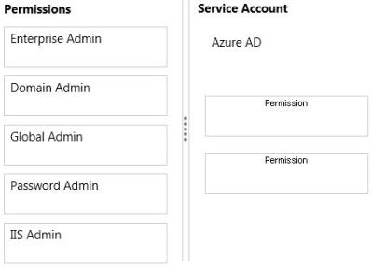

question_answerVIEW ANSWER

SHOW COMMENTS3

Answer :

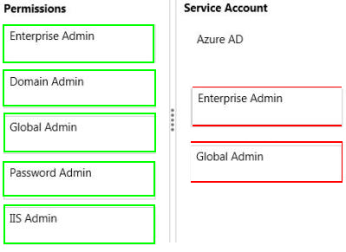

Explanation: Box 1: Enterprise Admin Box 2: Global Admin When you run the Directory Sync tool Configuration Wizard, you must provide the following information: Enterprise admin credentials for the on-premises Active Directory schema Global admin credentials for the Microsoft cloud service https://support.microsoft.com/kb/2684395?wa=wsignin1.0

##### Question No : 114 -

Your company is launching a public website that allows users to stream videos.  
You upload multiple video files to an Azure storage container.  
You need to give anonymous users read access to all of the video files in the storage  
container.  
What should you do?

* **A.**Edit each blob's metadata and set the access policy to Public Blob.
* **B.**Edit the container metadata and set the access policy to Public Container.
* **C.**Move the files into a container sub-directory and set the directory access level to Public Blob.
* **D.**Edit the container metadata and set the access policy to Public Blob.

question_answerVIEW ANSWER

SHOW COMMENTS4

Answer : **C**

Explanation: By default, the container is private and can be accessed only by the account owner. To allow public read access to the blobs in the container, but not the container properties and metadata, use the "Public Blob" option. To allow full public read access for the container and blobs, use the "Public Container" option.

##### Question No : 115 -

You manage an Azure Web Site in Standard mode at the following address:  
contoso.azurevvebsites.net.  
Your company has a new domain for the site that needs to be accessible by Secure Socket  
Layer (SSL) encryption.  
You need to be able to add a custom domain to the Azure Web Site and assign an SSL  
certificate.  
Which three steps should you perform next in sequence? To answer, move the appropriate  
actions from the list of actions to the answer area and arrange them in the correct order.  
More than one order of answer choices may be correct You will receive credit for any of the  
correct orders you select

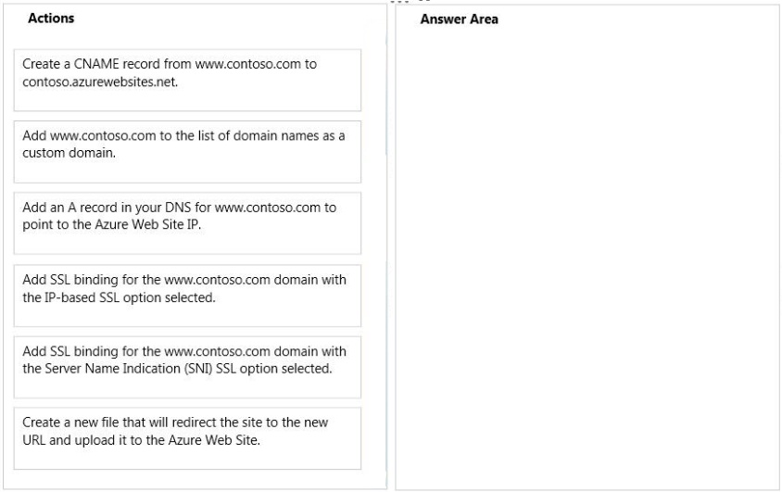

question_answerVIEW ANSWER

SHOW COMMENTS5

Answer :

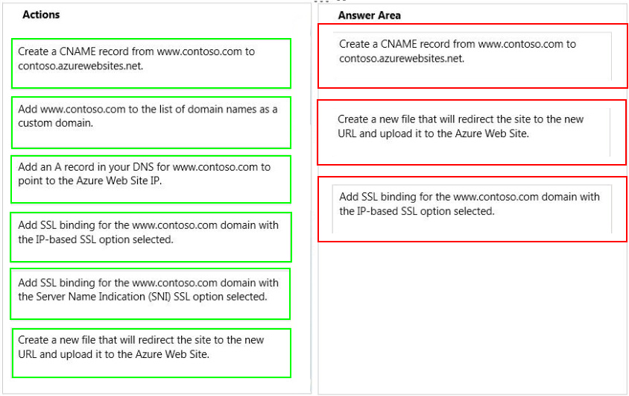

Explanation: Box 1:

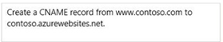

Box 2:

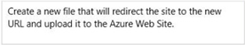

Box 3:

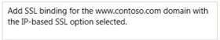

Step 1: When adding a CNAME record, you must set the Host Name field to the sub- domain you wish to use. For example, www. You must set the Address field to the .azurewebsites.net domain name of your Azure Website. For example, contoso.azurwebsites.net. Step 2: Modify the service definition and configuration files Your application must be configured to use the certificate, and an HTTPS endpoint must be added. As a result, the service definition and service configuration files need to be updated. Step 3: IP based SSL associates a certificate with a domain name by mapping the dedicated public IP address of the server to the domain name. This requires each domain name (contoso.com, fabricam.com, etc.) associated with your service to have a dedicated IP address. This is the traditional method of associating SSL certificates with a web server. References:

##### Question No : 116 -

You manage two cloud services named Service1 and Service2. The development team  
updates the code for each application and notifies you that the services are packaged and  
ready for deployment.  
Each cloud service has specific requirements for deployment according to the following  
table.

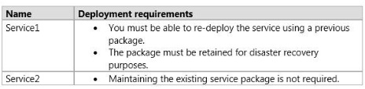

In the table below, identify the deployment method for each service. Make only one  
selection in each column.

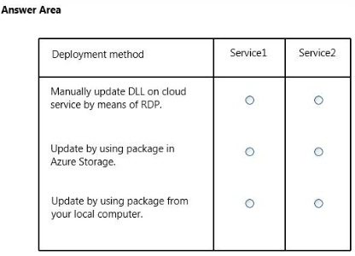

question_answerVIEW ANSWER

SHOW COMMENTS0

Answer :

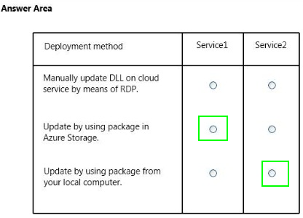

Explanation:

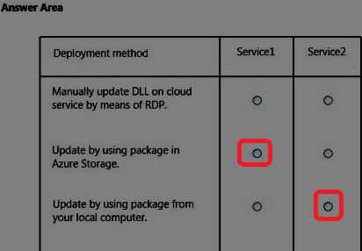

* Service 1 As the package must be retained we should deploy it through the Azure Storage cloud. * Service 2 As maintaining the existing storage package is not required we can deploy the package locally. * Azure service package Whenever you want to deploy your application to a Cloud Service youll be creating a Service Package and upload it, together with the Service Configuration to a deployment in a Cloud Service. These two artifacts are what makes up a Cloud Service deployment. References:

##### Question No : 117 -

You administer a set of virtual machine (VM) guests hosted in Hyper-V on Windows Server  
2012 R2.  
The virtual machines run the following operating systems:  
All guests currently are provisioned with one or more network interfaces with static bindings  
and VHDX disks. You need to move the VMs to Azure Virtual Machines hosted in an Azure  
subscription.  
Which three actions should you perform? Each correct answer presents part of the  
solution.

* **A.**Install the WALinuxAgent on Linux servers.
* **B.**Ensure that all servers can acquire an IP by means of Dynamic Host Configuration Protocol (DHCP).
* **C.**Upgrade all Windows VMs to Windows Server 2008 R2 or higher.
* **D.**Sysprep all Windows servers.
* **E.**Convert the existing virtual disks to the virtual hard disk (VHD) format.

question_answerVIEW ANSWER

SHOW COMMENTS7

Answer : **A,C,E**

##### Question No : 118 -

You manage a virtual Windows Server 2012 web server that is hosted by an on-premises  
Windows Hyper-V server. You plan to use the virtual machine (VM) in Azure.  
You need to migrate the VM to Azure Storage to add it to your repository.  
Which Azure Power Shell cmdlet should you use?

* **A.**Import-AzureVM
* **B.**New-AzureVM
* **C.**Add-AzureDisk
* **D.**Add-AzureWebRole
* **E.**Add-AzureVhd

question_answerVIEW ANSWER

SHOW COMMENTS8

Answer : **C**

Explanation: References:

##### Question No : 119 -

Your company network has two branch offices. Some employees work remotely, including  
at public locations. You manage an Azure environment that includes several virtual  
networks.  
All users require access to the virtual networks.  
In the table below, identify which secure cross-premise connectivity option is needed for  
each type of user. Make only one selection in each column.

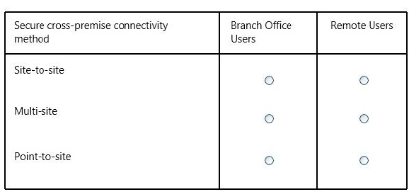

question_answerVIEW ANSWER

SHOW COMMENTS0

Answer :

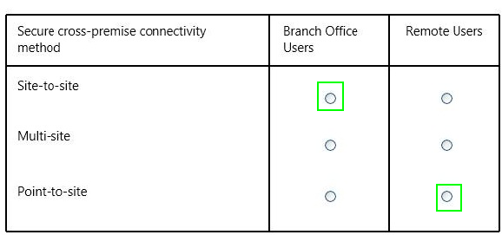

Explanation:

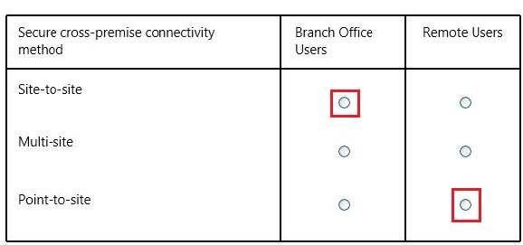

References:

##### Question No : 120 -

You administer an Azure Web Site named contosoweb that is used to sell various products.  
Contosoweb experiences heavy traffic during weekends.  
You need to analyze the response time of the product catalog page during peak times,  
from different locations.  
What should you do?

* **A.**Configure endpoint monitoring.
* **B.**Add the Requests metric.
* **C.**Turn on Failed Request Tracing.
* **D.**Turn on Detailed Error Messages.

question_answerVIEW ANSWER

SHOW COMMENTS0

Answer : **A**

Explanation: Endpoint monitoring configures web tests from geo-distributed locations that test response time and uptime of web URLs. The test performs an HTTP get operation on the web URL to determine the response time and uptime from each location. Each configured location runs a test every five minutes. After you configure endpoint monitoring, you can drill down into the individual endpoints to view details response time and uptime status over the monitoring interval from each of the test location References:

##### Question No : 121 -

You administer an Azure Storage account named contosostorage. The account has queue  
containers with logging enabled.  
You need to view all log files generated during the month of July 2014.  
Which URL should you use to access the list?

* **A.**http://contosostorage.queue.core.windows.net/$logs? restype=container&comp=list&prefix=queue/2014/07
* **B.**http://contosostorage.queue.core.windows.net/$files? restype=container&comp=list&prefix=queue/2014/07
* **C.**http://contosostorage.blob.core.windows.net/$files? restype=container&comp=list&prefix=blob/2014/07
* **D.**http://contosostorage.blob.core.windows.net/$logs? restype=container&comp=list&prefix=blob/2014/07

question_answerVIEW ANSWER

SHOW COMMENTS0

Answer : **D**

Explanation: All logs are stored in block blobs in a container named $logs, which is automatically created when Storage Analytics is enabled for a storage account. The$logs container is located in the blob namespace of the storage account, for example: http://<accountname>.blob.core.windows.net/$logs. This container cannot be deleted once Storage Analytics has been enabled, though its contents can be deleted. Note: Each log will be written in the following format: <service-name>/YYYY/MM/DD/hhmm/<counter>.log References:

##### Question No : 122 -

You manage a cloud service on two instances. The service name is Service1 and the role  
name is ServiceRole1.  
Service1 has performance issues during heavy traffic periods.  
You need to increase the existing deployment of Service1 to three instances.  
Which Power Shell cmdlet should you use?

* **A.**PS C:\>Set-AzureService -ServiceName “Service1” -Label “ServiceRole1” -Description “Instance count=3”
* **B.**PS C:\>Set-AzureRole -ServiceName “Service1” -Slot “Production” -RoleName “ServiceRole1” -Count 3
* **C.**PS C:\>Add-AzureWebRole -Name “ServiceRole1” -Instances 3
* **D.**PS C:\> $instancecount = New-Object Hashtable$settings[INSTANCECOUNT=3] PS C:\> Set-AzureWebsite -AppSettings $instancecount ServiceRole1

question_answerVIEW ANSWER

SHOW COMMENTS1

Answer : **B**

Explanation: The Set-AzureRole cmdlet sets the number of instances of a specified role to run in an Azure deployment Example This command sets the "MyTestRole3" role running in production on the "MySvc1" service to three instances. Windows PowerShell C:\PS>Set-AzureRole ServiceName "MySvc1" Slot "Production" RoleName "MyTestRole3" Count 3 References:

##### Question No : 123 -

Your company network includes two branch offices. Users at the company access internal  
virtual machines (VMs).  
You want to ensure secure communications between the branch offices and the internal  
VMs and network.  
You need to create a site-to-site VPN connection.  
What are two possible ways to achieve this goal? Each correct answer presents a  
complete solution.

* **A.**a private IPv4 IP address and a compatible VPN device
* **B.**a private IPv4 IP address and a RRAS running on Windows Server 2012
* **C.**a public-facing IPv4 IP address and a compatible VPN device
* **D.**a public-facing IPv4 IP address and a RRAS running on Windows Server 2012

question_answerVIEW ANSWER

SHOW COMMENTS0

Answer : **C,D**

Explanation: C (not A): VPN Device IP Address - This is public facing IPv4 address of your on-premises VPN device that youll use to connect to Azure. The VPN device cannot be located behind a NAT. D (Not B): At least one or preferably two publicly visible IP addresses: One of the IP addresses is used on the Windows Server 2012 machine that acts as the VPN device by using RRAS. The other optional IP address is to be used as the Default gateway for out- bound traffic from the on-premises network. If the second IP address is not available, it is possible to configure network address translation (NAT) on the RRAS machine itself, to be discussed in the following sections. It is important to note that the IP addresses must be public. They cannot be behind NAT and/or a firewall. References:

##### Question No : 124 -

You administer a Windows Server virtual machine (VM).  
You upload the VM to Azure.  
You need to ensure that you are able to deploy the BGInfo and VMAccess extensions.  
What should you do?

* **A.**Select the Install the VM Agent checkbox while provisioning a VM based on your uploaded VHD.
* **B.**Select the Enable the VM Extensions checkbox while provisioning a VM based on your uploaded VHD.
* **C.**Install the VM Agent MSI and execute the following Power Shell commands:$vm = Get- AzureVM -serviceName $svc -Name $name$vm.VM.ProvisionGuestAgent = $trueUpdate- AzureVM -Name Sname -VM $vm.VM -ServiceName $svc
* **D.**Install the VM Agent MSI and execute the following Power Shell commands:$vm = Get- AzureVM -serviceName $svc -Name $nameSet-AzureVMBGInfoExtension -VM $vm.VMSet-AzureVM Access Extension -VM $vm.VMUpdate-AzureVM -Name Sname -VM $vm.VM -ServiceName $svc

question_answerVIEW ANSWER

SHOW COMMENTS3

Answer : **B**

##### Question No : 125 -

You manage an application deployed to virtual machines (VMs) on an Azure virtual network  
named corpVnet1.  
You plan to hire several remote employees who will need access to the application on  
corpVnet1.  
You need to ensure that new employees can access corpVnet1. You want to achieve this  
goal by using the most cost effective solution.  
Which two actions should you perform? Each correct answer presents part of the solution.

* **A.**Create a VPN subnet.
* **B.**Enable point-to-point connectivity for corpVnet1.
* **C.**Enable point-to-site connectivity for corpVnet1.
* **D.**Create a gateway subnet.
* **E.**Enable site-to-site connectivity for corpVnet1.
* **F.**Convert corpVnet1 to a regional virtual network.

question_answerVIEW ANSWER

SHOW COMMENTS5

Answer : **A,C**

Explanation: A point-to-site VPN also allows you to create a secure connection to your virtual network. In a point-to-site configuration, the connection is configured individually on each client computer that you want to connect to the virtual network. Point-to-site connections do not require a VPN device. They work by using a VPN client that you install on each client computer. The VPN is established by manually starting the connection from the on- premises client computer. You can also configure the VPN client to automatically restart. References:

##### Question No : 126 -

You manage an Azure Active Directory (AD) tenant  
You plan to allow users to log in to a third-party application by using their Azure AD  
credentials.  
To access the application, users will be prompted for their existing third-party user names  
and passwords.  
You need to add the application to Azure AD.  
Which type of application should you add?

* **A.**Existing Single Sign-On with identity provisioning
* **B.**Password Single Sign-On with identity provisioning
* **C.**Existing Single Sign-On without identity provisioning
* **D.**Password Single Sign-On without identity provisioning

question_answerVIEW ANSWER

SHOW COMMENTS5

Answer : **A**

Explanation: * Azure AD supports two different modes for single sign-on: / Federation using standard protocols Configuring Federation-based single sign-on enables the users in your organization to be automatically signed in to a third-party SaaS application by Azure AD using the user account information from Azure AD. / Password-based single sign-on * Support for user provisioning User provisioning enables automated user provisioning and deprovisioning of accounts in third-party SaaS applications from within the Azure Management Portal, using your Windows Server Active Directory or Azure AD identity information. When a user is given permissions in Azure AD for one of these applications, an account can be automatically created (provisioned) in the target SaaS application. References:

##### Question No : 127 -

You manage a set of virtual machines (VMs) deployed to the cloud service named  
fabrikamVM.  
You configure auto scaling according to the following parameters:  
You discover the following usage pattern of a specific application:  
You need to modify the auto scaling configuration to scale up faster when usage peaks.  
What are two possible ways to achieve this goal? Each correct answer presents a  
complete solution.

* **A.**Decrease the scale down wait time.
* **B.**Decrease the scale up wait time.
* **C.**Increase the number of scale up instances.
* **D.**Increase the scale up wait time.
* **E.**Increase the maximum number of instances.

question_answerVIEW ANSWER

SHOW COMMENTS2

Answer : **B,C**

##### Question No : 128 -

You are the global administrator for a companys Azure subscription. The company uses  
Azure Active Directory Premium and the Application Access Panel. You are configuring  
access to a Software as a Service (SaaS) application.  
You need to ensure that the sales team lead is able to manage user access to the  
application but is unable to modify administrative access to the application.  
In the Azure portal, what should you do?

* **A.**Create an Azure group and assign it to the SaaS application. Create an Azure user with the User Admin role, and assign the user as the owner of the new group.
* **B.**Create an Azure group and assign it to the SaaS application. Create an Azure user with the Service Admin role, and assign the user as the owner of the new group.
* **C.**Set the values of the Delegated group management and Users can create groups settings to Enabled.
* **D.**Create an Azure group and assign it to the SaaS application. Create an Azure user with the Global Admin role, and assign the user as the owner of the new group.

question_answerVIEW ANSWER

SHOW COMMENTS1

Answer : **A**

##### Question No : 129 -

You administer an Azure Active Directory (Azure AD) tenant where Box is configured for:  
An employee moves to an organizational unit that does not require access to Box through  
the Access Panel.  
You need to remove only Box from the list of applications only for this user.  
What should you do?

* **A.**Delete the user from the Azure AD tenant.
* **B.**Delete the Box Application definition from the Azure AD tenant.
* **C.**From the Management Portal, remove the user's assignment to the application.
* **D.**Disable the user's account in Windows AD.

question_answerVIEW ANSWER

SHOW COMMENTS0

Answer : **C**

Explanation: Note: Use Azure AD to manage user access, provision user accounts, and enable single sign-on with Box. Requires an existing Box subscription.

##### Question No : 130 -

You deploy an Azure Web App named ContosoApp.  
You configure a Traffic Manager profile for ContosoApp.  
You need to create the required DNS record to redirect queries to ContosoApp from the  
Internet. The solution must ensure that remote users can connect to ContosoApp by using  
the https://webservice.contoso.com URL.  
Which DNS record should you create? To answer, select the appropriate options in the  
answer area.

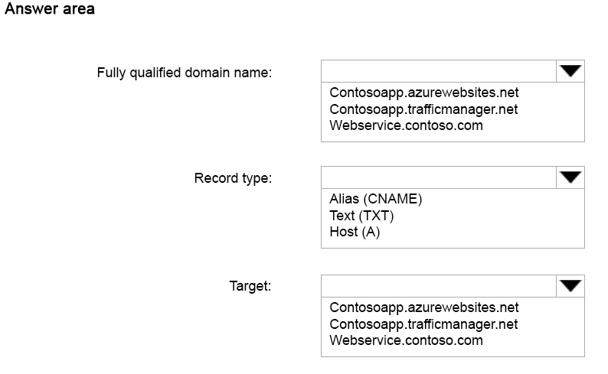

question_answerVIEW ANSWER

SHOW COMMENTS2

Answer :

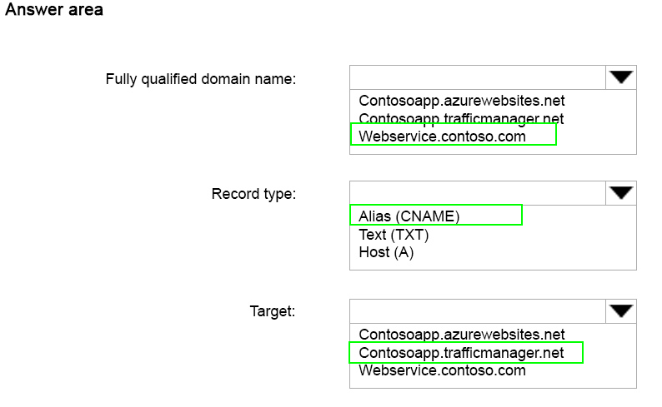

Explanation:

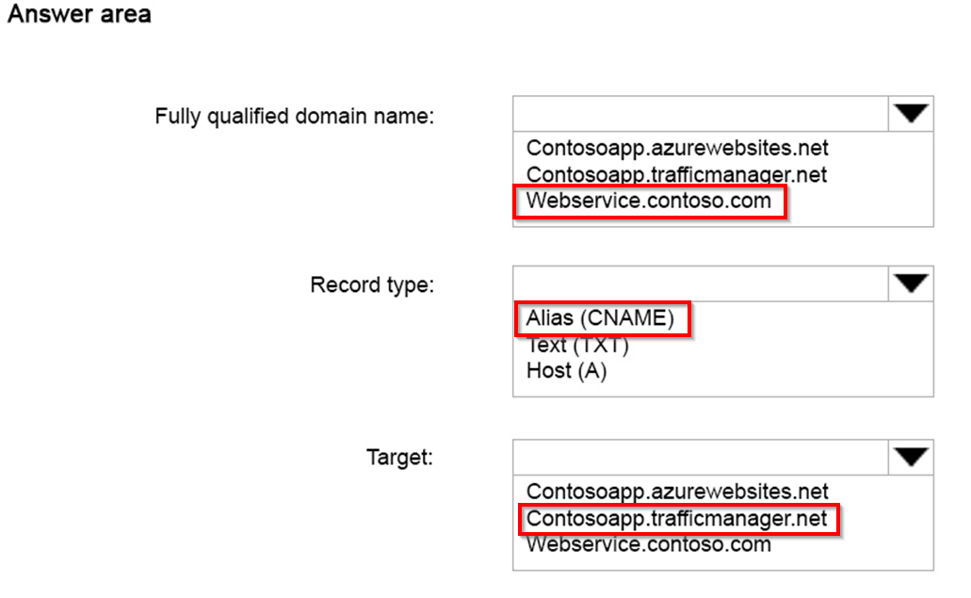

References: https://azure.microsoft.com/en-gb/documentation/articles/web-sites-traffic-manager- custom-domain-name/